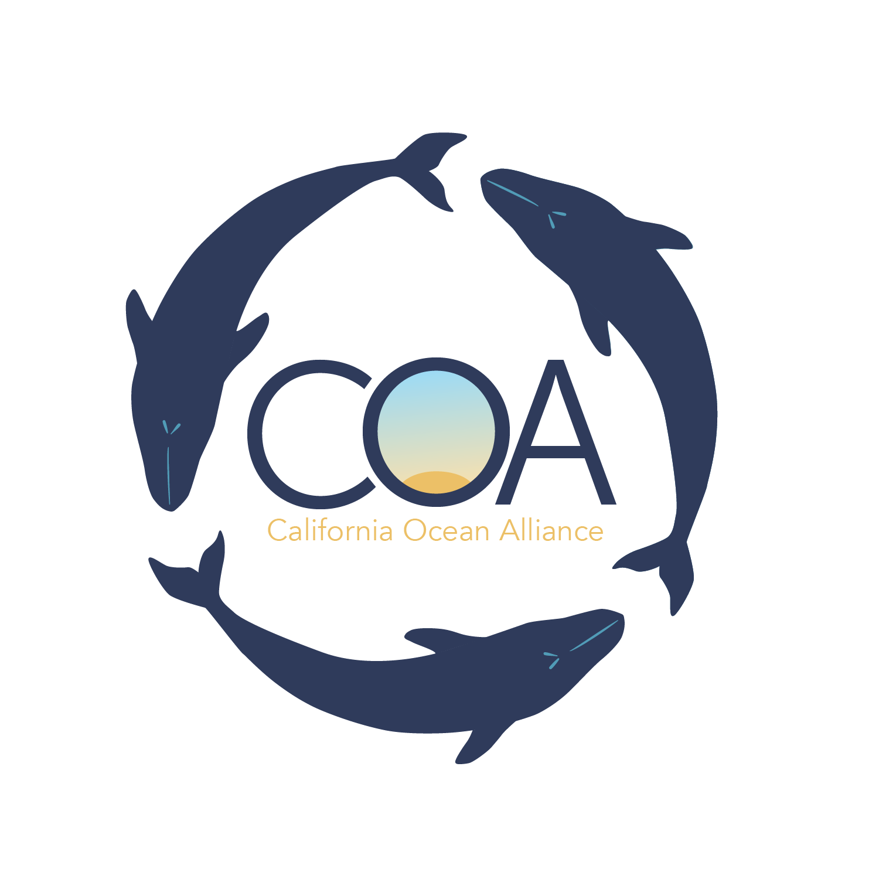
Marine Mammal Scientists in Training Course Application
Summer 2020

General Information:

Student’s Name (First and Last):

Parents’/Guardians’ Names (First and Last):

Mailing Address:

Phone (Mobile):

Student’s Birthday:

Student’s grade (upcoming):

Student’s tee-shirt size: (S, M, L, XL)

Emergency Contact #1: (name, phone, and relationship to student):

Emergency Contact #2: (name, phone, and relationship to student):

Student’s e-mail address:

Parent or guardian’s e-mail address:

The student above plans to arrive to the camp by: (please circle one)

Walking/riding bike
Car Ride from: ________________________ relation to student: __________________
Bus

The student above plans to depart the camp by: (please circle one)

Walking/riding bike
Car Ride from: ________________________ relation to student: __________________
Bus

Do you wish to be considered for financial support? If so, please write “YES” below, and include a secondary document explain your reasons, your combined family income, and how much financial aid you hope to receive (total cost of the program is $1,100).

Please indicate the week you hope to attend Marine Mammal Scientists in Training course below (provide a for 1=first choice, a 2 =second choice, and a 3-third choice). Each session is limited to 12 students.

July 6-10 July 20-23 August 3-7

Does the student have any allergies or medical conditions we should be aware of?
Is the student prone to motion sickness?

How did you hear about COA’s Educational Programs?

Does the student have any previous experience with marine mammals or field research?

Parent Signature ___________________________________________ Date: _______

Student Signature ___________________________________________ Date: _______

General Questions and Personal Essay:

What are the future goals of the applicant?

Any additional comments?

On a separate piece of paper, please explain (in less than 500 words) why you wish to attend the Marine Mammal Scientist in Training course, and what about marine mammals you are most excited to learn about.

Applicant Agreement:

Please send this application and your personal essay no later than 5pm on June 20th 2020 to the Marine Mammal Scientist-In-Training Director, Caroline Casey, by email ccasey@caoceanalliance.org or by mail at:
California Ocean Alliance, Org.
Attn: Marine Mammal Scientist-In-Training Application
9099 Soquel Drive, Suite 8
Aptos, California 95003

*Applications will be accepted until June 20th, however placement into the program is based on a first-come first-serve basis

Thank you so much for your interest in the Marine Mammal Scientist-in-Training Program!

