Project Learning Tree: A “hands-on” approach to learning | By Morgan Smith

Have you ever found yourself doodling or daydreaming in a class or meeting? Ever thought, “I don’t think I can listen to this person talk for another minute.” Now imagine the opposite. Think of a time when you were so interested in a topic or excited about an activity that you did not want it to end.
Many environmental education organizations replace dry lectures with entertaining, “hands-on” activities. An example of one such organization is Project Learning Tree.
Project Learning Tree is an American Forest Foundation program that provides educators with ideas for lessons about the natural world that are suitable for many audiences. Most of the lessons use hands on activities that include multiple learning styles.
In order to reach these goals, Project Learning Tree holds many workshops designed for teachers.
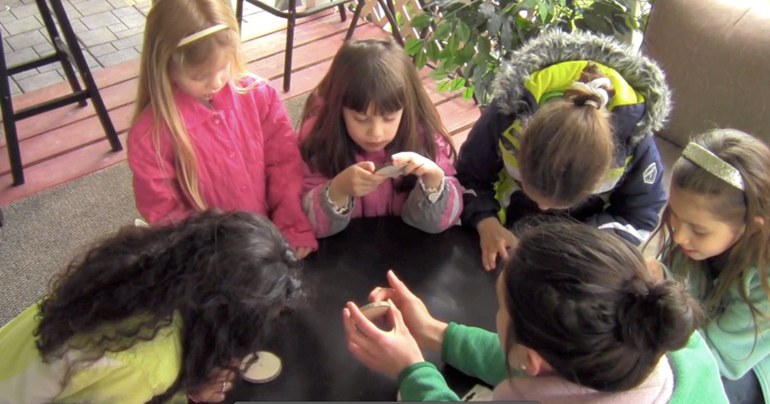
What do you do at a workshop?
Workshops come in many shapes and sizes. Types of workshops include Early Childhood, PreK-8, and Secondary Modules, which are designed for high school and college level students. They range in length from two hours, to full weekends, to semester-long workshops in some cases.
The main goal of the workshops is for instructors to learn how to use Project Learning Tree materials and activities in their own lessons. At the end of the workshop, those who attended receive curriculum guides for the age level of that workshop.

Do the workshops work?
Great question! In 2012, Sara Velardi, a PhD candidate of SUNY College of Environmental Science and Forestry (SUNY ESF) began a two year study that looked into the value of the New York State Project Learning Tree workshops. Sara is an expert in environmental education with a Master’s degree in Environmental Interpretation from SUNY ESF.
Figure 1: Sara administers a Project Learning Tree activity called "Tree Cookies" in which participants learn about tree growth through tree rings. (Photo credit: Sara Velardi)

How did she do it?
Sara began her study by surveying some of the people in charge of New York State’s Project Learning Tree workshops. The surveys included questions about types of workshops, limitations of workshops, workshop attendance, and what resources may make the workshops more successful.
Educators that had gone to a Project Learning Tree Workshop were also sent an online survey. The survey asked about when the workshop had taken place, what type of workshop it was, and how each person has used the Project Learning Tree activities in their own lessons since the workshop.
Sara then met with some of the people who had responded to her survey for one-on-one interviews. In the interviews, she was able to dive deeper into the details of their experiences at the workshops. Sara was also able to ask about how they had used their new knowledge in their own lessons.

What did she find?
It turns out that most of the educators do use the Project Learning Tree activities in their lessons at least a few times a year. Teachers that went to a workshop for high school and college level audiences were two to three times more likely to use the Project Learning Tree programs monthly to weekly.

What did the educators like about the workshops?
Instructors enjoyed the “hands-on” portions of the workshops most. They also enjoyed the workshops that took less time, had a clear theme, and focused on a more specific audience.
Sara did ask workshop members if they would have rather been a part of an online workshop to save them more time. She found that most people preferred the in-person workshops because of the hands-on aspect.

What does this all mean?
In terms of Sara’s first question that asked about the value of the workshops, the study suggests that Project Learning Tree workshops are a useful tool for teachers.
Sara hoped to learn more about how much of what was taught at each workshop was used after the fact. Her results suggest that people who attended the Secondary Module workshops used what was taught there more than the other workshops.
This could be due to the fact that they were focused on a more specific audience, were shorter than most other workshops, and because they tended to have a specific theme.
It seems that Project Learning Tree is a useful tool for all educators that touch on the natural world even rarely. It is a great way to get ideas for lessons that actively involve the audience and inspire exploration of environmental subjects.

