CONTACT:

Susan Friedman - (703) 660-1273

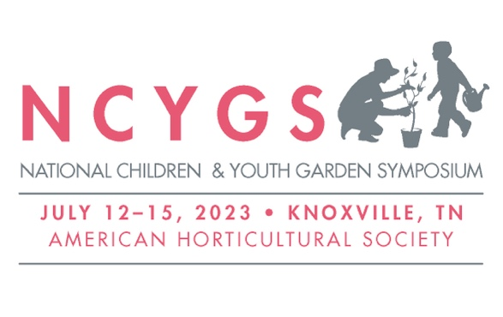
sfriedman@ahsgardening.org

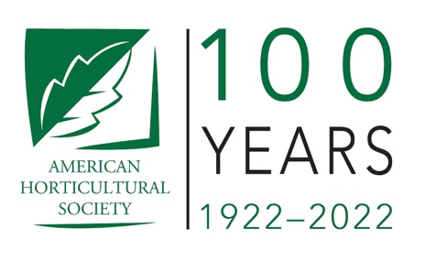

For Immediate Release

American Horticultural Society’s National Children & Youth Garden Symposium Call for Sessions Deadline Extended to January 13

Alexandria, VA – January 10, 2023 – Deadline to submit presentation proposals for the American Horticultural Society’s National Children & Youth Garden Symposium has been extended to Friday, January 13.
In partnership with University of Tennessee Institute of Agriculture and UT Gardens, NCYGS 2023 will be held in Knoxville, July 12 – 15. NCYGS is the longest running national event where garden educators (pre-K through 12th) convene to learn about current trends in nature-based education and share resources, best practices, and inspiring stories with peers across the country.
Presentations should be adapted for a diverse audience of classroom teachers, “informal” educators from a variety of organizations, botanical gardens staff, landscape architects, program coordinators, and more. Sessions may be presented in either a lecture or workshop format. Additional guidelines and proposal writing tips can be found on the AHS website, as well as last year’s sessions.
Notifications regarding the status of each proposal will be sent out in February, and selected presenters will receive a discounted rate to attend the Symposium.
Read more about NCYGS 2023 and submit your presentation proposal by January 13. For questions, please contact education@ahsgardening.org.

About American Horticultural Society
Celebrating 100 years, the non-profit American Horticultural Society is one of the most respected and longstanding member-based national gardening organizations in America. Through our educational programs, awards and publications, AHS connects people to gardening, raises awareness of earth-friendly gardening practices, introduces children to plants, brings together leaders to address important national issues, and showcases the art and practice of horticulture. www.ahsgardening.org
###

