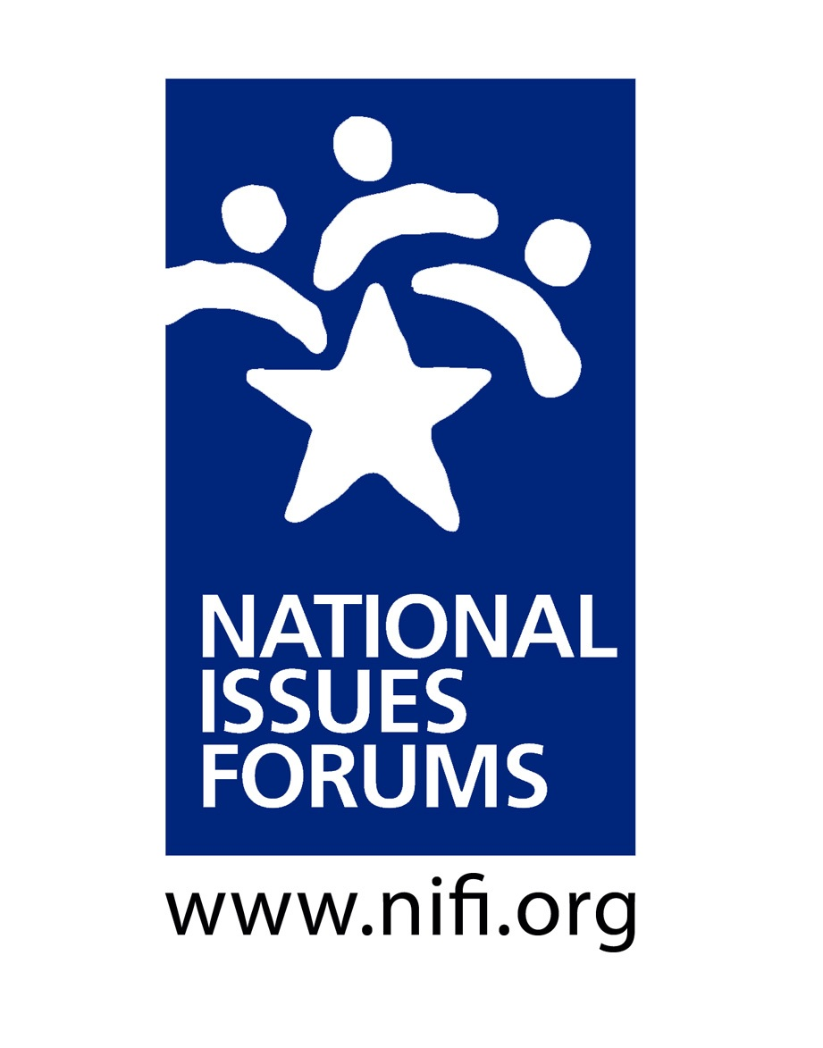

Introduction & Ground Rules ___ minutes
Purpose: Look at Alternative Approaches to the Issue and Hear Different Points of View
- This is not a debate; we’re not here to “win” an argument. We’re here to listen and learn.
- We’ll look carefully at alternative approaches—all of them with trade-offs and drawbacks.
- At the close of the forum, we’ll reflect on what we’ve heard—looking for common ground, but also recognizing remaining areas of tension. We’ll identify areas where we ourselves might be willing to reconsider.
- We’ll try to think about what matters most to us and what we are willing to give up to make progress on resolving this issue.

My Role: Serve as Impartial Facilitator
- I’m here to help us have a conversation that is as deliberative as possible.
- I’ll encourage everyone to consider different viewpoints.
- I’ll watch the time to ensure we talk about all the options and have time for reflections at the end.
- From time to time, I may point to specific questions and ideas in the guide, especially if they represent voices not in the room or trade-offs we haven’t talked about.
- This is your conversation. Please talk to and listen to each other.

Structure: The Four Parts of a Deliberative Forum
- Ground Rules
- Personal Stake
- Deliberating on the Options: Option 1, Option 2, Option 3
- Closing Reflections

Ground Rules ___ minutes

Some sample ground rules used by forum moderators
- Listen to other voices. Listening is as important as speaking.
- Consider each approach fairly, looking at its benefits and its trade-offs.
- Everyone is encouraged to participate. No one or two individuals should dominate.
- It’s okay to disagree, but do so with curiosity, not hostility. Learning more about how others think is one of the most interesting parts of a forum.
- Keep an open mind. Avoid coming to conclusions until we’ve deliberated on all the options.
- Are there additional ground rules we would like add?
- Do we all agree to follow these ground rules and hold one another accountable to them?

Personal Stake: ___ minutes
Some questions moderators often use to encourage participants to talk about their personal stake in the issue
- Why did you come out to the forum today?
- What aspect of the issue concerns you most?
- How has this issue affected you, your family, or your community?
- When you think about this issue, what bothers you?
- How does this problem impact the things in your life and community that are most important to you?

Option 1: Recap and Questions for Deliberation ___ minutes
This option says the way we talk about public issues is pushing us apart. On TV, online, and in our own lives, it doesn’t take long to find examples of Americans calling each other names, spinning the truth, and assuming their opponents are immoral or corrupt. Therefore, we should empower media and online companies and important institutions like universities to take action against uncivil, abusive rhetoric. BUT this gives these decision-makers enormous power to determine what people can say about each other or about public issues. Who gets to decide what’s “outrageous” and what’s not?

- Curtailing free speech harms our democracy. But doesn’t abusive, dishonest political rhetoric do the same thing by driving people away from politics? What’s the right balance here?
- The “outrage industry” continues because it’s popular—it boosts TV ratings and increases clicks online. Is there any practical, realistic way to make users to behave more responsibly?

Option 2: Recap and Questions for Deliberation ___ minutes
This option says our current political system is tilted toward those with money and influence who use the rules for their own benefit and oppose all efforts at compromise. To fix our system, we need to make changes that will encourage compromise and broader participation. We should remove obstacles to voting, limit money in politics, and allow nonpartisan commissions to draw Congressional districts based on population patterns, not party politics. BUT this focus on compromise could hinder people’s right to fight for what they believe in. Doesn’t our system need more fundamental change?

- Some of the nation’s worst decisions were the result of compromise, notably the acceptance of slavery by the founding fathers. Would more compromise help, or would it move use further away from doing what’s right?
- Are the requirements for voting really so burdensome? Isn’t it fair to expect people to clearly identify themselves? Wouldn’t this end up giving too much power to those who aren’t willing to put in the effort to register and go to the polls?

Option 3: Recap and Questions for Deliberation ___ minutes
This option argues that we have placed too much power in the hands of a remote national government, which often doesn’t understand local conditions. Therefore, we should allow states and local communities to make more of our decisions about education, healthcare, energy, poverty, and other important issues. BUT won’t this option produce a patchwork of rules on major national challenges that harms our country as a whole? Won’t this put people at the mercy of local decision-makers who may or may not defend their interests?

- This option assumes that local decisions will be better decisions, but what happens to people living in areas where local decision-makers are biased or corrupt or inept?
- What will happen if citizens focus mainly on local problems and issues? How will our country look in 20 years if we basically throw up our hands about national government?

Closing Reflections ___ minutes

Acting on the ideas and proposals presented here will bring about changes that affect all of us, in every city and town, and none of them is guaranteed to produce the results we want. It is important to think carefully about the implications of the ideas presented here—to consider how they could improve our politics and, EQUALLY IMPORTANT, how they might misfire and make our problems worse.

As we think back on our conversation, here are some important questions to consider:

- Now that we have deliberated, are there ideas or viewpoints you hadn’t considered before?
- Can you now identify any shared concerns or hopes we have discovered in our conversation?
- How has what you heard affected your thinking?
- Are there other people or groups you would like to hear from, now that you’ve begun to weigh some of options before us?
- What could you do as an individual?
- What could your community do? How likely is it that your community would take up this challenge?
- What do we want our elected officials in Washington to do? Are our expectations reasonable?
- Can you identify any tensions that came up during the forum?
- What questions remain? What work do we still need to do?

