Green Careers Toolkit

This toolkit provides higher education (faculty and staff) curated access to resources and processes, organized to aid in teaching about and engaging students in exploring green careers and what it means to be a sustainability professional. By researching potential green career opportunities and the skills and credentials needed, students can enhance their resumes and improve their employability upon graduation.
USGBC is here to help you apply these resources to your courses. Please contact us at education@usgbc.org to let us know how you’ve customized use of these resources to meet your course needs. Also, please let us know if there are additional resources that will further support your efforts. We look forward to hearing stories about your green building and sustainability courses.
Contents
Career Support on Campus 1
Green Careers 2
Student Activities 8
Presentation/Teaching Resources 9
LEED Credentials 10
Additional USGBC Resources and Opportunities 10
Appendices 12

Career Support on Campus
Higher education students seek green career advice from multiple areas on campus. Each source can provide valuable green career support. This toolkit can provide each of those areas with resources and processes to engage students in exploring green careers.
Faculty: provide academic advising, incorporate presentations and activities into the classroom, or facilitate LEED Lab courses on campus.
Career Development Office: offer green career advising, resources for exploring careers, career fairs, lead workshops and make alumni connections.
Office of Sustainability: provide green career and green building resources and offer work and/or intern opportunities.

Green Careers
Integrating sustainability across the curriculum prepares this generation to be both global citizens and champions in addressing some of the biggest challenges we face. The workplace is rapidly changing, as are employer expectations. Sustainability is now being driven into core businesses and is the lens through which companies assess their operations.
9.8 million jobs requiring green tasks
70% of organizations have permanently placed sustainability on their management agendas
65% of businesses value environmental and sustainability knowledge in job candidates
78% of businesses said environmental and sustainability knowledge would grow in importance as a hiring factor in the next five years
60% of new jobs in the 21st century will require a background in STEM
Defining “green jobs”:
There are different ways of defining ‘green jobs’. According to the U.S. Bureau of Labor Statistics, they are “jobs in businesses that produce goods or provide services that benefit the environment or conserve natural resources.”
But just about any occupation can have an impact on the environment. The "greening" of occupations refers to the extent to which green economy activities and technologies increase the demand for existing occupations, shape the work and worker requirements needed for occupational performance, or generate unique work and worker requirements.
Businesses continue to see the value of sustainability and will need to hire employees that support their mission and goals:
- 62% of global business leaders think that integrating sustainability into business operations is their company’s most important leadership challenge.
- 76% of CEOs believe that embedding sustainability into their core business will drive revenue growth and new opportunities.
- 49% of CFOs believe there is a strong link between sustainability performance and financial performance.

Desire for a green job:
According to MonsterTRAK (now MonsterCollege), which focuses on new graduates, as many as 80% of young professionals would like to work in a green job. This bodes well for the future – the growing passion for finding “green-collar” jobs means that the green and sustainable markets will benefit from the skills and vision of new graduates.
And from an article in the The Economist, "According to a survey by Net Impact, an industry association, more than 70% of college students and 50% of workers are looking for jobs with social impact. Nearly 60% of students are even willing to take pay cut in order to work for a company that represents their values."
It is important that a student’s college experience is relevant to the career they wish to pursue. A recent survey has shown the more relevant that people find their courses to be in their work and daily lives, the greater their belief that they received a high-quality education and that it was worth the cost. In fact, consumers who strongly agree their courses are relevant to their careers and lives are 63 percentage points more likely to strongly agree their education was worth the cost and 50 percentage points more likely to strongly agree they received a high-quality education.
The purpose of this toolkit is to prepare students for 21st century careers using sustainability as a solutions driver. The materials can be adapted and scaled to fit a variety of class topics, degree programs, campus initiatives, and student learning levels and provide content for experiential learning, helping to prepare students for the needs of the 21st century.
These materials do not provide a prescriptive path or set curriculum, rather we encourage you to select resources that are right for your classes or programs. These can be applied as teaching material, student activities, or as supplemental resources to share with students and graduates. The materials are designed to support hands-on learning to address employers’ desire for stronger skills in critical thinking, complex problem solving, written and oral communication, and applied knowledge in real-world settings.
Green Career Resources:
Green Jobs (Bureau of Labor Statistics): www.bls.gov/green/ and www.bls.gov/green/greencareers.htm
Careers in Green Construction (Bureau of Labor Statistics): www.bls.gov/green/construction/
Career One Stop Green Careers: www.careeronestop.org/GreenCareers/green-careers

Green Building Careers
The following green careers are prevalent in the green building industry. For a list of other careers with possible ‘green tasks’ see the Appendix.

Acoustical engineer/consultant
Architect
Attorney
Brownfield redevelopment specialist
Commissioning agent
Compliance manager
Construction subcontractor trades (carpenter, plumber, electrician, mason)
Cost estimator
Electrician
Energy auditor
Energy modeler
Engineer (civil, electrical, mechanical, plumbing, structural)
Facilities management (manager, staff)
General contractor/Construction Manager
HVAC technician (design, installation, maintenance)
Interior Designer
Landscape architect
Mechanical, electrical, plumbing (MEP) contractor (design, installation, maintenance)
Property managers
Renewable energy technician (design, installation, maintenance)
Supply chain manager
Sustainability consultant
Urban Planner

The following resource examples can help you and the students learn more about these professions.

Career | Definition/Relation to green building | Resource Examples
Acoustical engineer/ consultant | Acoustical engineers and consultants help design buildings to best carry sound or work with construction teams to minimize noise pollution from their projects. | - Audio Engineering Society  - Institute of Noise Control Engineering  - International Institute of Noise Control Engineering
Architect | Architects plan and design all forms of buildings, including green buildings. | - O*Net: Architect  - Occupational Outlook Handbook: Architects  - American Institute of Architects  - National Council of Architectural Registration Boards
Attorney | Attorneys are experts in law and can support green buildings by helping with contracts, compliance with green building codes, and negotiations between different stakeholders. | - O*Net: Lawyer  - “A Lawyer's Role In Green Building”  - “So, You Want to Be a Green Building Attorney”
Brownfield redevelopment specialists and Site managers | These specialists develop plans for and provide oversight of the remediation and redevelopment of contaminated brownfield sites, a key component of sustainable site development and general environmental health. | - O*Net: Brownfield Redevelopment Specialists and Site Managers  - BLS: Careers in Environmental Remediation
Commissioning agent | Building commissioners thoroughly test buildings and systems before occupancy to ensure that everything performs as expected. They can ensure that all systems are designed to achieve their sustainability goals. | - Building Commissioning Association  - Association of Energy Engineers  - American Society of Heating, Refrigerating and Air-Conditioning Engineers: Commissioning Process Management Professional Certification  - Build Green DC: Commissioning
Compliance managers | Compliance managers ensure that organizations comply with regulatory and ethical standards, including developing environmental compliance plans and conducting audits. | - O*Net: Compliance Manager  - Compliance and Accreditation Manager’s Association
Cost estimator | Cost estimators determine the costs, labor, materials, and time needed for projects, including buildings. Many specialize in green buildings. | - O*Net: Cost Estimators  - American Society of Professional Estimators  - Association for the Advancement of Cost Engineering International (AACE International)  - International Cost Estimating and Analysis Association  - Occupational Outlook Handbook: Cost Estimators
Electrician | Electricians work with electric wiring and equipment, including planning, conducting, and inspecting their installation. Green buildings require electricians to help with designing, selecting, and installing sustainable electric options such programmable thermostats, Energy Star appliances, and dimmer light switches. | - O*Net: Electricians  - Electrical Training Alliance  - Home Builders Institute  - Independent Electrical Contractors  - International Brotherhood of Electrical Workers  - National Electrical Contractors Association  - Occupational Outlook Handbook: Electricians  - National Electrical Contractors Association
Energy auditor | Energy auditors audit building and system energy use and identify opportunities for increased energy efficiency. | - O*Net: Energy Auditors  - Association of Energy Engineers  - National Institute for Certification in Engineering Technologies  - Bureau of Labor Statistics: Energy Auditors
Energy modeler | Energy modelers use blueprints and computer software to model a building’s energy systems and measure their energy efficiency. | - Association of Energy Engineers
Engineer (civil, electrical, mechanical, plumbing, structural, energy) | Engineers design, build, maintain, and repair the systems of their specialty. Those commonly involved in building construction include mechanical, electrical, energy, and civil engineers. | - O*Net: Civil Engineers  - O*Net: Energy Engineers  - O*Net: Electrical Engineers  - O*Net: Mechanical Engineers  - ASHRAE  - National Society of Professional Engineers  - Occupational Outlook Handbook: Mechanical Engineers  - Occupational Outlook Handbook: Civil Engineers  - Occupational Outlook Handbook: Electrical Engineers
Environmental scientists and specialists | Environmental scientists and specialists use their knowledge of the natural sciences to protect the environment and human health. | - O*Net: Environmental scientists and specialists  - Occupational Outlook Handbook: Environmental scientists and specialists
Facilities manager | Facility managers plan, execute, and oversee the daily operations of buildings, which vary significantly depending on the building’s function. They have the ability to enhance the performance of buildings and ensure that any implemented green features run smoothly. | - O*Net: General and Operations Managers  - International Facility Management Association  - Building Owners and Managers Association International  - American Management Association  - Institute of Certified Professional Managers  - National Management Association  - International Public Management Association for Human Resources  - Occupational Outlook Handbook: Administrative Services Manager
General contractor/ Construction Manager | A general contractor coordinates the entire construction process, including overseeing the day-to-day operations of the project and maintaining communications between all parties. | - O*Net: Construction Manager  - Project Management Institute  - Occupational Outlook Handbook: Construction managers  - The Associated General Contractors of America
HVAC technician (design, installation, maintenance) | HVAC (heating, ventilation, and air conditioning) technicians design, install, maintain, and repair heating, air conditioning, and refrigeration systems. They can help improve the energy efficiency of buildings with technological adjustments. | - O*Net: Heating and Air Conditioning Mechanics and Installers  - Occupational Outlook Handbook: Heating, air conditioning, and refrigeration mechanics and installers  - ASHRAE  - Air Conditioning Contractors of America
Interior designer | Interior designers plan and implement a design for internal spaces with a goal of enhancing the function and quality of the spaces. Interior designers play a significant role in green buildings through their material choices and designs that minimize inefficient energy and low air quality. | - O*Net: Interior Design  - Occupational Outlook Handbook: Interior designers American Society of Interior Designers  - Council for Interior Design Qualification  - International Interior Design Association
Landscape architect | Landscape architects plan and design outdoor spaces such as parks, campuses, and residential and commercial sites. They play a large role in creating sustainable spaces through designs that improve energy efficiency, conserve water, use sustainable materials and support resiliency efforts. | - O*Net: Landscape architects  - Occupational Outlook Handbook: Landscape architects  - American Society of Landscape Architects  - Council of Landscape Architectural Registration Boards
Mechanical, electrical, plumbing (MEP) contractor | MEP contractors design, install, and maintain a building’s mechanical, electrical, and plumbing systems, which significantly impact a building’s energy and water use. | - Mechanical Contractors Association  - Council of American Mechanical & Electrical Engineers
Property manager | Property managers maintain properties, oversee their operations, and coordinate leasing. They have significant control over what green additions to include in their building, such as sourcing cleaning supplies and high efficiency light bulbs, and whether to work with buyers and companies with green values. | - O*Net: Property, Real Estate, and Community Association Managers  - Property Management Association  - Occupational Outlook Handbook: Property Managers
Renewable energy technician  (design, installation, maintenance) | Renewable energy technicians could include wind turbine technicians, solar technicians, nuclear technicians, biofuel technicians, bio-plant technicians, or hydroelectric plant technicians. They help install, operate, monitor, and repair these technologies. | - O*Net: Wind Turbine Service Technicians  - O*Net: Solar Energy Systems Engineers  - Occupational Outlook Handbook: Wind turbine technicians  - Occupational Outlook Handbook: Solar photovoltaic installers  - American Wind Energy Association  - Solar Energy Industries Association
Supply chain manager | Supply chain managers coordinate and direct aspects of a supply chain including distribution, purchasing, and warehousing to streamline or improve the process. Their work can impact the environment through their selections of materials, manufacturers, transportation, and disposal options. | - O*Net: Supply Chain Manager  - Council of Supply Chain Management Professionals  - Institute for Supply Management  - APICS
Sustainability consultant | Sustainability consultants work with clients to help them improve the sustainability performance of their business and buildings. | - O*Net: Sustainability Specialist  - International Society of Sustainability Professionals
Urban planner | Urban planners develop plans for the design of cities, towns, jurisdictions, etc. They can advise on strategies to meet sustainability and resiliency goals. | - O*Net: Urban Planners  - Occupational Outlook Handbook: Urban and regional planners  - American Planning Association  - American Institute of Certified Planners  - Planning Accreditation Board

Student Activities
      - Craft personal mission statements. Students reflect on and determine their interests and values in order to identify the type of career that would best suit them.
      - Position themselves for a green job. Create an ‘elevator pitch’ about themselves to potential employers.
      - Conduct informational Interviews. Students research companies or leaders in a field that interests them and conduct interviews to gain knowledge about the industry and potential career paths.
      - Attend an external event related to a potential career and network with participants to gather professional advice.
      - Role play to discuss how different careers impact the triple bottom line (planet, people, profit).
      - Use the O*Net database to explore and connect careers and search for jobs.
      - Explore career sites for open job postings in potential careers to identify what employers are looking for.
      - Assign reports and articles to students to generate discussion and reflection. These can be conducted in class or as class assignments and can be done individually or in groups (see Appendix for suggested reports and resources).
      - Prepare for a LEED credential over the semester. Provide reading assignments and conduct reviews or mock exams in class.
      - Encourage student internships or job shadowing experiences. Identify local companies or organizations with green careers and arrange opportunities for students to intern or shadow professionals.
See the Appendix for activity guidelines, instructions, and additional resources.

Presentation/Teaching Resources
Brochures:
“What is LEED”
“Green Careers”
Presentation Slides:
Green Careers Slides
LEED and Green Building
Education @USGBC: Subscription access to the Education @USGBC catalog features more than 600 hours of green building and sustainability education. This growing library highlights best-in-class courses and resources to grow knowledge and fulfill continuing education for LEED credentials, AIA, and others. (The Green Careers Toolkit page calls out a list of selected content in the Education @USGBC Subscription that align with teaching about green careers). Watch the video to find out what is included in the Education @USGBC platform and the three subscription options for post-secondary instruction.

Invite alumni and local green building and sustainability professionals to join your course to share their career experiences and advice.

- USGBC Member Directory links to USGBC member companies and their employees. Link: http://www.usgbc.org/people/member-employees
- USGBC & GBCI Speaker Request Form facilitates connections between USGBC representatives and your class. Link: https://usgbc.wufoo.com/forms/usgbc-gbci-speaker-request-form/
- USGBC Faculty Directory presents a global network of credible, qualified instructors, teachers and facilitators. Link: http://www.usgbc.org/people/usgbc-faculty
- Reach out to your local USGBC community and connect directly with LEED projects and teams in your area. Search the USGBC Organizations Database by region to connect with USGBC near you. Link: https://www.usgbc.org/organizations/region

USGBC Articles. Search by topics or sort by channels. Sign up for email subscriptions to receive new articles directly.

USGBC’s YouTube Channel. Suggested playlists: Big Ideas at USGBC and video interviews with climate leaders.

USGBC+. USGBC’s bi-monthly magazine with stories and strategies behind the world’s greenest buildings. The current and archived issues are available online here.

We encourage you to consider the wide range of USGBC public resources that can be incorporated into your teaching materials. Contact education@usgbc.org to talk about how you can be creating innovative curriculum by accessing best-in-class content & resources for 21st century learning.

LEED Credentials
Prepare students to earn a LEED credential.
71% of hiring decision makers maintain that being credentialed increases competitiveness and 85% of credentialed professionals believe that their credential gives them a competitive edge in the job market.
LEED Green Associates have a documented, up-to-date understanding of the most current green building principles and practices and are committed to their professional future.

LEED Accredited Professional is an advanced professional credential signifying expertise in green building and a LEED rating system.

USGBC Micro-Credentials. Demonstrate knowledge with green building digital badges. These include:
Green Classroom Professional
LEED Lab
USGBC Knowledge-Based Badges

Additional USGBC Resources and Opportunities
LEED Resources
  - LEED: www.usgbc.org/leed
  - LEED rating systems: http://leed.usgbc.org/
General USGBC resources:
  - USGBC website. Information about the U.S. Green Building Council and its programs.
  - USGBC Higher Education. Receive the latest information on the resources and products to support higher education sustainability efforts on campus.
  - GBCI website. Information about Green Business Certification Inc., the administration of LEED project certifications, and professional credentials and certificates.
  - Arc. This state-of-the-art platform allows you to collect, manage and benchmark your data so you can improve sustainability performance.
  - USGBC Student page. Encourage students to sign up for a free usgbc.org user account and check off the “I am a student” box to receive discounts and access to additional resources. Encourage them to create a profile in the USGBC Student Directory.
  - USGBC email subscriptions. Sign up and get emails to stay informed on LEED and other USGBC activities. (Requires a free usgbc.org user account if not a member).
  - USGBC Career Center. Searchable database of green building job openings.

- Both USGBC members and nonmembers may create a free usgbc.org user account and create a public profile for the USGBC Directory

- Become a USGBC Faculty for up-to-date instructional resources, exclusive training opportunities to maintain your competitive edge in the market, and visibility across USGBC’s digital platforms. Benefits include a complimentary Education @USGBC subscription and a complimentary GBCI CE course review.
Discounts for Institutions and Students
Currently, USGBC offers student discounts to individuals who indicate they are a student in their USGBC account. This includes discounts on USGBC products including the LEED v4 web-based reference guide ($50), Education @USGBC subscription ($99), publications (USGBC member price) and the LEED Green Associate exam ($100).
Looking for resources to teach about other green building topics? Check out the Higher Education Curricular Toolkits for resources and processes to aid in teaching about and engaging students in the concepts of sustainability including: green building, LEED, sustainable land design and development, and zero waste.

For additional Higher Education support or to provide feedback on these resources, please contact education@usgbc.org.

Appendices

Appendix: Possible Green Careers
Appendix: Activity Guidance
Appendix: Job Search Sites
Appendix: Reports and Resources
Appendix: Credentials/Certificates

Appendix: Possible Green Careers
List of occupations that can contain ‘green tasks’ and therefore have an impact on the triple bottom line (people, planet, profit)
Green industries/fields

Advocacy/non-Profit  Agriculture  Animal management  Architecture  Commissioning  Construction  Consulting  Ecology  Education  Energy conservation  Energy modeling  Engineering  Environmental services  Facility maintenance/operations  Food (production, processing)  Forestry | Government (city, state, federal)  Hydrology  Interior design  Landscape architecture  Legal  Manufacturing  Natural resources  Natural sciences  Power systems  Public health  Real estate development  Renewable energy  Urban planning/design  Utilities  Waste management

Green careers

- Accountant and Auditor
- Activist
- Acoustical engineer/consultant
- Administrative support staff
- Agricultural inspector
- Air quality specialist
- Architect
- Architectural drafter
- Automotive engineer
- Biofuel technician (design, installation, maintenance)
- Biofuel production manager
- Biologist
- Brownfield Redevelopment Specialist and Site Manager
- Chief Sustainability Officer
- Clean car engineer
- Climate change analyst
- Compliance manager
- Commissioning agent
- Community planner
- Conservationist
- Construction subcontractor (carpenter, plumber, electrician, mason)
- Consultant
- Corporate Social Reporting (CSR) Director
- Cost estimator
- Daylighting consultant or modeler
- Ecotourism guide
- Electric Power Line Installer and Repairer
- Electrician
- Energy auditor
- Energy broker
- Energy engineer
- Energy modeler
- Engineer, civil
- Engineer, electrical
- Engineer, mechanical
- Engineer, plumbing
- Engineer, structural
- Environmental anthropologist
- Environmental documentarian
- Environmental economist
- Environmental educator
- Environmental engineer
- Environmental fiction writer
- Environmental journalist
- Environmental lawyer
- Environmental restoration planner
- Facilities management staff
- Facilities manager
- Fish and game warden
- Forest conservationist
- Fuel Cell Engineer
- General contractor/Construction Manager
- Geological Sample Test Technician
- Geoscientist
- Geospatial information scientist and technician
- Geothermal technicians/production manager
- Graphical Information Systems (GIS) technician
- Green artist (photographer, painter, sculptor)
- Green marketers/communication director
- Hazardous materials removal manager
- Hydroelectric plant technician/production manager
- Hydrologist
- HVAC technician (design, installation, maintenance)
- Interior Designer
- Industrial ecologist
- Industrial Engineering technologist
- Investor
- Investment underwriter
- Land surveyor
- Landscape architect
- Lobbyist
- Maintenance and Repair Worker
- Mechanical, electrical, plumbing (MEP) contractor (design, installation, maintenance)
- Meter Reader, Utilities
- Methane/Landfill Gas Collection System Operators/Technician
- Collection System Operator
- Natural Scientist
- Nanosystems engineer
- Natural science manager
- Non-profit sector professional
- Nuclear power operator
- Photonics engineer/technician
- Power Plant Operator
- Precision operator technician
- Product designer
- Program coordinator/manager/director
- Property manager
- Public health official
- Real estate agent
- Recycler (manager, coordinator, hauler)
- Renewable energy technician (design, installation, maintenance)
- Solar/photovoltaic technician (design, installation, maintenance)
- Solar sale representative and assessor
- Soil conservationist
- Supply chain manager
- Sustainability consultant
- Sustainability specialist
- Transportation planner
- Urban grower
- Urban Planner/Designer
- Water and Liquid Waste Treatment System Operator
- Water/wastewater engineer
- Water Conservationist
- Water resource specialist
- Water quality technician
- Wave energy technician (design, installation, maintenance)/manager
- Weatherization Installer and Technician
- Zoologist and wildlife biologist

Appendix: Activity Guidance

Activity: Crafting a personal mission statement

Objective: Create a personal mission statement for guidance and clarity in career exploration.

This is a writing exercise of self-reflection. Mission statements are often utilized as an organizational management tool and are a valuable tool for individuals as well. This activity encourages you to think deeply about your strengths, aspirations, and how you define success. The outcome will be a personal mission statement you can refer to for guidance and clarity as you move into your career.

Instructions:
Write a personal mission statement that is a concise summary of what you hope to accomplish in your career, the values that guide your work, your highest aspirations, the impact you hope to make in the world, or any combination of these things. Most importantly, it should be comprehensive and meaningful to you, while still being short. Reach for the stars and don’t hold back, you can accomplish what you set out to do!

Example
“I teach to inspire. I will practice humility, kindness and respect for all living things and in doing so I will inspire these qualities in others, slowly but surely creating a world where every human can thrive.”

Use these questions to help you think about important elements of your mission statement.

- What brings you happiness?
- What is your favorite quality about yourself?
- What is your greatest professional strength?
- How have you used this strength in the past to help a person, group, or organization?
- How would you like to utilize this strength in the future?
- How could you take this strength and refine or improve upon it?
- What do you do to stay motivated during difficult times?
- When you are feeling uninspired, how do you regain a sense of excitement or motivate yourself to continue?
- What qualities are key to a fulfilling personal relationship? What qualities are key to a fulfilling professional relationship?
- What qualities do you hope other people see in you?

Core Values

Another exercise that can help generate ideas and self-awareness when crafting a personal mission statement is listing your core values. Below are a set of guidelines for completing this exercise.

- Make a list of your top 3-5 core values and rank them.
- If time allows, take a few days to write down values that pop into your head throughout the day.
- After a few days, look over the list and chose the ones that feel most important to you.

Additional Resources

The TED talk by Scott Dinsmore, titled How to Find Work You Love, is an excellent summary of the importance of defining a personal mission statement and taking time for self-reflection.
Link: http://www.ted.com/talks/scott_dinsmore_how_to_find_work_you_love?language=en#t-250969

The Franklin Covey Institute personal Mission Statement Generator
Link: http://msb.franklincovey.com/

Activity: Position yourself with an elevator pitch

Objective: Create a ‘elevator pitch’ to position yourself for a job.

An ‘elevator pitch’ is a succinct and persuasive personal introduction about yourself. It should be short and direct, 30 seconds to 2 minutes. And it should clearly explain who you are and what you have to offer in a way that makes the listener want to know more.

The description generally explains your skills and goals, and why you would be a productive and beneficial person to have on a team or within a company or project. Remember the point is not just to talk about you but to talk about how you can help a company or organization.

Types of elevator pitches for job searching:

There are different ways to structure the pitch. But they all have the same goals. Get the listener’s attention and get them to want to hear more. And always end with a ‘call to action’ or an ‘ask’ to continue the conversation.

Who – What – Why + Ask (Who you are, What you can do, Why you want to do it + Ask)
I am an architecture major that worked on certifying a campus building to achieve LEED O+M certification. I am looking to put those green building skills to work on more projects and help build a more sustainable society. What green building experience does your firm need?

Action – Impact – Call to Action (What you do, why you do it, and the impact it makes on others and a request)

I worked on a LEED Lab project that earned our campus dorm LEED O+M certification. My focus was on the green purchasing and waste policies. I believe that implementing some simple and practical strategies to reduce waste is a key step towards a better environment. Through my work I was able to help the project earn an additional point in LEED. Can you connect me to someone on your Facilities Management team I can talk to about how I can bring that knowledge to your company?

Studies – Reason – Ask (Why you are studying what you are and what you are looking for)

I am an environmental studies major with a focus on ecosystems because I’ve seen damage our built environment is taking on the natural resources in my hometown. I am looking to take my knowledge and passion to work for a non-profit with a sustainability mission. Who do you recommend I talk to at your organization to learn more about your work and how I might fit in?

Instructions:

Create an elevator pitch explaining why you are the right person for the job.

Adapt it to create multiple versions/variations of it for different situations. These could include:
- 30 second version and 2 minute version
- Introduction during a job fair
- Opening statement in a job interview

Practice your elevator pitch with other students and share feedback for improvements. The more you practice, the more confident and natural you will sound when presenting it to future employers.

Additional Resources:

https://www.thebalancecareers.com/elevator-speech-examples-and-writing-tips-2061976
https://www.indeed.com/career-advice/interviewing/how-to-give-an-elevator-pitch-examples
https://careersidekick.com/best-elevator-pitch/
https://www.recruiter.com/i/how-to-write-a-sure-fire-elevator-pitch-for-your-job-search/

Activity: Informational Interview
“A meeting featuring a conversation about a particular company or industry between you and someone who may be in a position to help you get a job in the future, either directly or indirectly” (Andy Teach, author of From Graduation to Corporation).

Objective: Conduct research to gain deeper understanding of an industry.

This is your opportunity to conduct research and gain a deeper understanding of an industry you are interested in learning more about. Through this research, you will learn which companies are leaders in the field, what their mission and vision is, and where there are located. In the next phase of this activity, scheduling and conducting an informational interview, you will gain first-hand knowledge from a professional about the industry and career path that might be available to you. Finally, you may have the chance to compile your findings and reflections into a short presentation to share with your class.

Instructions:
- Determine an industry you want to learn more about.
- Gather information about this industry following the Research Guidelines.
- Reach out to professionals and schedule an informational interview, following the Informational Interview Guidance.
- After the interview, create a short presentation about what you learned from the experience, following the Presentation Guidelines.
Research guidelines:

Step 1: Brainstorm the industries and career fields you would like to learn more about. Pick one to focus on for your informational interview.

Step 2: Research your chosen industry. The following questions can be used as guidance.
  - What are the long-term challenges and opportunities for this industry relating to social justice, environmental sustainability and economic prosperity?
  - What organizations are leaders in this field?
  - What organizations are incorporating the Triple Bottom Line framework into their work? How are they doing this in practice?
  - What type of job opportunities are available to me in this industry and what skills or knowledge would they be looking for?

Interview guidelines:

Step 1: Determine companies and professionals you would like to interview. An in-person interview is ideal, so begin by looking for companies and professionals in your area.
  - Begin by talking to people in your network who might have connections in the industry of your choice. Utilize resources through your academic advisor, career center or other academic programs (e.g., business school) to help make these connections as well.
  - Conduct online research about the organizations in your area that are working in your area of interest.
  - Identify potential candidates for your informational interview.

Step 2: Schedule an informational interview following the steps below.
  - Prepare a succinct introduction that includes a quick summary of yourself, the reasons you are reaching out for an informational interview, and how you selected and got in touch with this person. Most professionals are familiar with the concept of an informational interview, but it is still a good idea to reiterate that your intention is to get to know the industry better, not to land a job.

  - Call or email to schedule the interview. When calling, have your summary on hand, know your availability, and on the off chance they want to have the interview right away, have your questions prepared. When emailing, keep the email brief and professional, and if you have a tight schedule, summarize the times you would be available for the interview. See the sample phone / email script below for guidance.

Step 3: Conduct the informational interview.
- Before the interview, research the organization and the professional you are interviewing. Prepare at least 5 questions and your Personal Mission Statement. See the example interview questions below for guidance.
- In addition to being prepared for the interview, it is also important to arrive on time and be dressed professionally. The interview is an opportunity to establish a key contact in your professional network and these considerations will help you make a good first impression.
- During the interview, use your prepared questions as needed, but remember to be courteous and attentive to what the interviewee wants to talk about as well. Aim to keep the overall tone relaxed and friendly, more like an informational meeting rather than a formal job interview. Feel free to take notes throughout the conversation. Finally, be prepared to talk about yourself too. If your Personal Mission Statement is ready to share, that’s a good thing to have on hand.
- Keep an open mind about your career interests during these interviews. It is not unusual to discover that your perception of a career is different than the reality, and this can cause you to like a career or industry more or less than you might have expected. Your trajectory might change over the course of your initial job search and your career itself. There are many ways to match your passions and interests to a specific position, company or industry. Be encouraged by this and take every opportunity as a learning experience.

Sample phone / email script:
Hello, my name is Jane Doe and I am a business student at the Green College. My academic advisor, Mr. Connections, gave me your contact information because he knows I am interested in environmental law, your area of expertise. I am especially interested in your perspective on the current state of the industry and any industry trends you are seeing related to sustainability. Although I am not looking for a job yet, I am hoping to learn as much as I can now in order to prepare for a career in this field. Would you be interested in setting up a 20-30 minute informational interview? I could come by your office anytime on Fridays or we could talk over the phone, whatever works best for you. Thank you for your time, I look forward to our meeting on Friday.

Sample Questions:

These are general questions to get the conversation going. Feel free to ask specific questions related to the industry or career path you're investigating.
- What motivated you to pursue this career and what steps did you take to get here?
- Do you have a personal mission that guides you in your work? If so, how did you come to clarify this mission? (This question can be used to open up a discussion in which you share your own personal mission statement.)
- What do you enjoy most about your job day-to-day?
- What are the biggest challenges you face in your job?
- How do you envision this industry progressing in the future?
- How, if at all, is the industry applying the Triple Bottom Line sustainability framework? (Be prepared to define the Triple Bottom Line and sustainability.)
- Do you have any advice for a student or young professional interested in this industry?

Presentation Guidelines

The following questions can be used as a guideline for creating a presentation back to the class.

- What is the industry/field you researched? What led you to that decision?
- How did you find information on the industry/career path?
- Who did you meet with? Why did you choose this person?
- Which of your expectations were confirmed?
- What did you learn that was different than you expected?
- What was your experience sharing your personal mission statement?
- What was the most valuable takeaway of the experience for you?

These informational interviews are an opportunity for you as students and young professionals to practice professional interactions in a more informal and casual setting than a formal job interview. It can be great practice for speaking and building confidence before an actual job interview.

Activity: External Event + Networking Activity
Objective: Hear directly from the perspective of a green professional and have the opportunity to directly engage with people in that sphere.
Instructions:
Attend one external event over the course of the semester that involves green professionals. This could be a panel discussion, guest speaker lecture, conference, political or legal gathering, or any other event that involves both hearing from the perspective of a person(s) whose career has green elements and a networking opportunity.

During the event, take notes about what the speaker(s) say regarding statistics, industry trends and advice. If there is an opportunity for discussions and Q+A, don’t be afraid to speak up and add to the discussion with your perspective or questions.

After the event, network with at least two people. If you have the opportunity to speak with one of the speakers, some suggested talking points are; asking how they got into the field, if they belong to any professional societies or have any professional credentials, what advice do they have for someone starting out in the field, or where do they see the field going in the future. If you’re speaking with a guest, feel free to ask them how they heard about the event or what brought them there, what they thought about the event, and what they do and why the event was of interest to them. Any of these openings could get a conversation flowing, so be ready to answer information about yourself in return!
Afterwards, prepare a 1-2 page report answering the following questions:
1) What green careers did they talk about?
2) What did you learn about the green career?
3) What were your biggest takeaways?
4) What questions do your still have about their job?
4) Whom would you recommend this event to?
5) Whom did you network with?
6) What did you talk about?

Activity: Role Play
Objective: Consider how different green careers impact the triple bottom line (planet, people, profit).
Instructions:
Each student is assigned to a green career and answers the selected scenario questions from the perspective of a leader in that discipline. Multiple students may be assigned to the same career and they can discuss their answers in class together after the assignment is due and come up with a consensus for one student to report to the class. Scenarios where the perspectives are in some conflict lends to students being able to question and challenge each other during the in-class portion and creates a richer role-play experience.
Students can be split into groups depending on the class subject and class size. Options for jobs to select can come from the Green Building Career list in the toolkit or from the Appendix of possible green careers.
Useful resources to research careers:

www.onetcenter.org/green.html
www.bls.gov/ooh
www.myplan.com/careers/index.php
www.thebalancecareers.com/career-briefs-525860
www.mynextmove.org

Scenario 1:
The United States government has decided to support the advancement of the UN Sustainable Development Goals. It wants to create public-private partnerships and bring together leaders from different fields for discussions on how to best distribute its financial resources. One of these roundtables brings together environmental leaders from a wide variety of fields to hear their perspectives. From the perspective of your assigned group, which goals would you agree are the most practical and important to focus on and how does your field help with it? In other words, why should any funding meant to advance the Sustainable Development Goals go to you? For example, an environmental anthropologist might feel like they’ve witnessed how reducing global inequalities (goal 10) is an essential first step towards remediating many environmental concerns and their work helps bring this to light, moving people to understand it. A landscape architect might say that sustainable cities and communities (goal 11) is the foundation for large-scale environmental improvements and their work supports the design of sustainable places.
Think about the following questions to help guide your answer (1-2 pages).
- As a professional in your field, what goal/goals do you think are the most important? Why?
- How does your work help with this goal?
- What could you do with more funding to advance this goal?
- Does your industry and its related goals have any overlap or connections with others? If so, how can multiple goals be achieved by industries working together?

In class, you’ll split into your groups and discuss your answers (10 minutes). Then, have one person from each group present as though explaining their answer to the President (5 minutes each). After, people from any group can ask questions from the perspective of their group to anyone in another group to challenge them or get more information.
Scenario 2:
The Advertising Council has announced its intention to run a pro bono Public Service Announcement for an environmental issue and asks different fields to submit their ideas for raising awareness. The winner receives free advertising and an outlet to demonstrate their commitment to the environment. From the perspective of your assigned group, write what you would include in this PSA to convince the Advertising Council that your organization has a unique perspective on environmental work that would capture people’s attention. For example, an interior designer might describe how they would emphasize the statistic that people spend 90% of their time inside and suggest showing an idyllic outdoor setting before panning to people breathing in VOCs from office material and paint indoors, which teaches people about indoor air quality while advertising the importance of good interior design. Get creative!
Think about the following questions to guide your answer.
1. As a professional in your field, in what ways do you deal with environmental concerns?
2. How could you express that in a concise and interesting way to the general public? Consider the communication tactics and messaging that would be most effective and garner the desired response from the public.
3. How would this PSA benefit your company as well as the environment?
In class, everyone can have a chance to briefly present their proposal before voting on whom they would have chosen for the PSA.
Scenario 3:
The Environmental Protection Agency (EPA) has drafted a series of regulations aimed to protect natural resources and curb greenhouse gas emissions and submitted them for public comments. They’re facing harsh opposition from individuals and organizations who accuse them of stifling economic growth because of their niche concerns. To the EPA’s surprise, individuals representing a wide variety of professions, many not traditionally associated with environmentalism, come to their defense and argue that bolstering the green economy actually creates many jobs at all levels allowing for more specialization, and improving the overall well-being of society. From the perspective of your assigned group, write the specific comments you might write to express these ideas. For example, an electrical engineer may write about how they were able to differentiate themselves from the competition by focusing on designing and installing electrical systems that utilize less energy and integrate natural lighting.
“The green economy encompasses the economic activity related to reducing the use of fossil fuels, decreasing pollution and greenhouse gas emissions, increasing the efficiency of energy usage, recycling materials, and developing and adopting renewable sources of energy” (O*Net Center).
Think about the following questions to guide your answer.
1. How does working in your field contribute to the green economy?
2. Are there environmentally-oriented certifications or skills that people in your field can get to advance their career or distinguish themselves?
3. How has working in your field introduced or enforced ideas about sustainability and its
importance to you?
4. How can a green economy encourage a society that is more environmentally friendly and socially responsible? In other words, consider the green economy in terms of the triple bottom line.

Activity: MyNextMove

Objective: Students explore knowledge, skills, abilities, personality, technology, education and job outlook information for a targeted career.

My Next Move is sponsored by the U.S. Department of Labor, Employment & Training Administration, and developed by the National Center for O*NET Development.

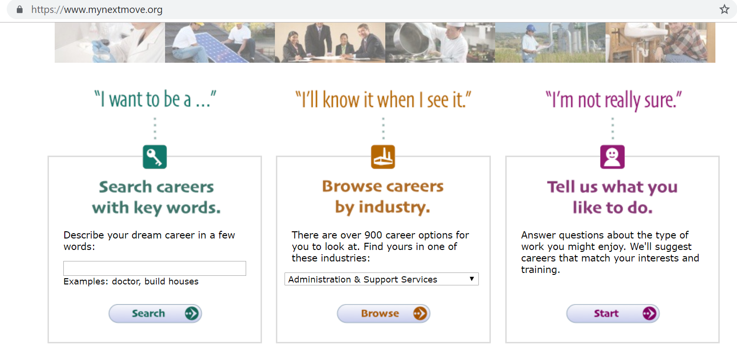
Options include ability to search a career with some key words or browse careers by industry.
The Interest Profiler helps to identify careers that may be a good fit for you based on the student’s interest. Students answer a series of questions that will provide a number of traits they have as well as potential positions that they may like and would be qualified for.

Activity: O*Net Activity (Part 1: Green Careers)
Objectives:
    - Consider new green career options based on your skills and interests.
    - Recognize the interconnections between careers and how your skills and interests are transferable across sectors.
Instructions:
Using the resource O*Net: Green Economy, create a flow chart that connects ten careers across a variety of sectors through their shared tasks or skills.
The template and example linked here: Template and Example
How to navigate O*Net:
- Go to www.onetonline.org.
- On the top left, click the tab “Find Occupations” then click “Green Economy Sector.”
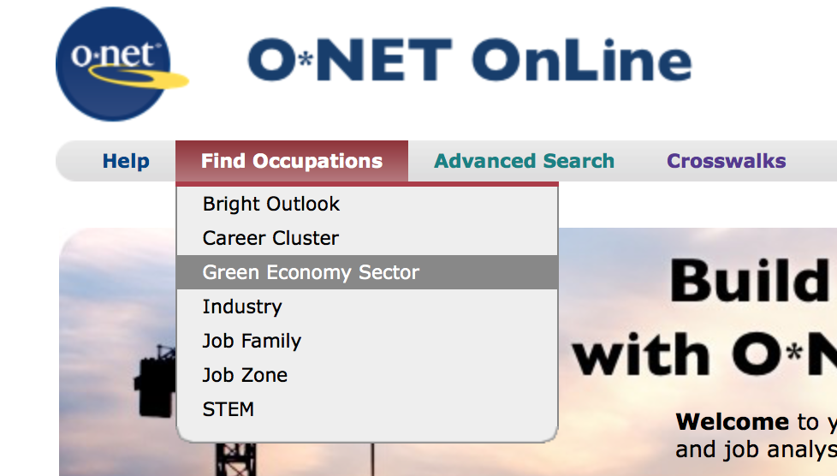
- Use the scroll down menu to navigate to each sector. Click on any sector to begin.
- Click any of the job title lists to see information about the job, including tasks, skills, knowledge, work activities, education, wages and employment trends.
- To see the full list of each section, click the plus sign under the section title (top arrow).
- To see what other jobs have the same task/skill/activity etc., click the plus sign next to the specific task/skill/activity (bottom arrow).
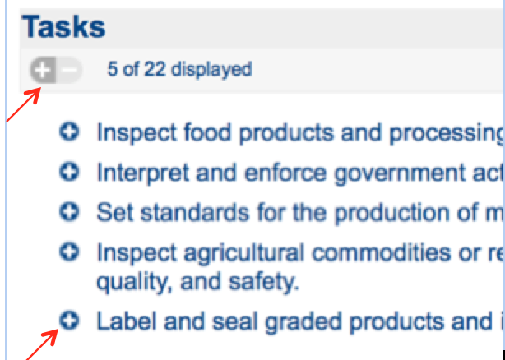

- A table will pop up showing careers with closely related or the same tasks. Click on “see more related occupations” at the bottom of the table for the full list (bottom arrow) and check for a “green job” symbol, a green leaf, next to the job (top arrow). Click one of the jobs to navigate to it.
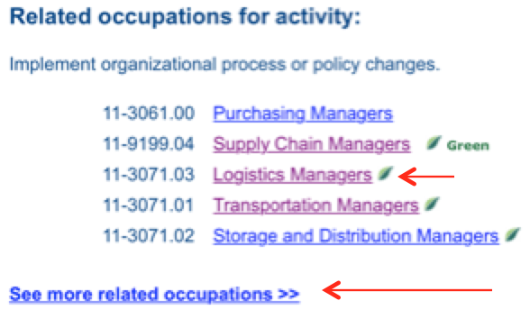

(If applicable) When you finish, post your flow chart onto the class homework page. Comment on at least one other student’s flow chart and mention a connection that surprised you or anything you find interesting about their assignment.

Template model for flow chart:
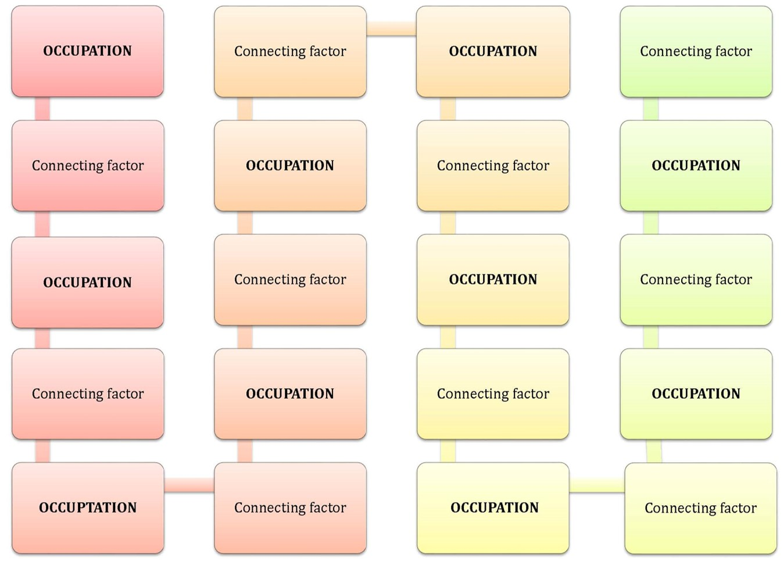

Example:
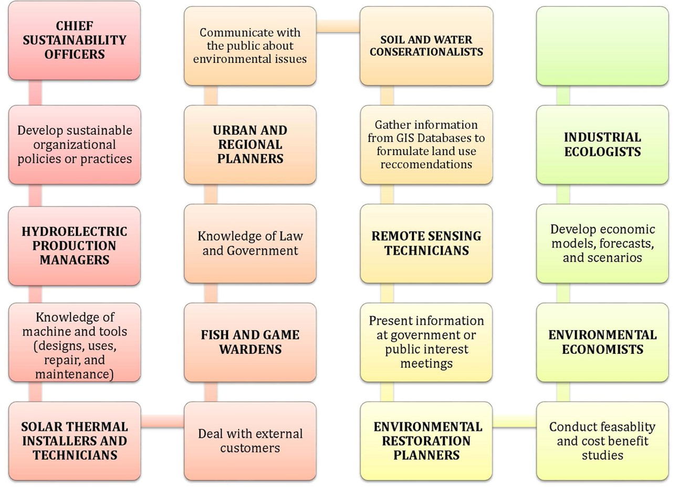

Activity: O*Net Activity (Part 2: Reflections and Job Search Practice)
Objectives:
    - Reflect about what was found on O*Net.
    - Practice looking for a job through search engines to understand how to navigate them.
    - Identify qualifications for positions that interest you.
Instructions:
Once you finish the career flow chart (Activity Part 1), reflect on the following questions (~1 page). What career or field surprised you by having environmental elements, or what green careers were you surprised existed? What surprised you about what you saw in any of the sections (task, skills, etc.)?
Then, choose one career you would want to learn more about and see if you can find job openings related to it. If you find multiple, note what overlaps in qualifications you’re seeing. Good websites to supplement general job search sites (Indeed.com, Glassdoor.com) are:
environmentalcareer.com
bsr.org/en/careers/job-openings
careercenter.usgbc.org
ecoemploy.com
ecojobs.com
environmental-jobs.com
greenjobsearch.org
jobmonkey.com/greenjobs
jobs.environmentalscience.org/
jobs.greenbiz.com
sustainablebusiness.com/greendreamjobs
usgbc.org/jobs
conservationjobboard.com/
environmentalscience.org/careers/
Try using keywords found in the O*Net page to help you. If you can’t find any openings, what other jobs did you end up coming across in your searches?
Example answer:
I hadn’t considered how a marketing major could lead to a green career before this activity. After reading about it, it makes sense that with the growing influx of environmentally conscious products, companies would want people not only familiar with marketing but also with environmental ideas and how to brand them. As more and more businesses incorporate sustainability into their services, people in this position will only become more desirable. I was also surprised by the wide variety of tasks associated with this position. It included research and analysis-heavy tasks such as analyzing green product trends and collecting data as well as creative work with creating or revising marketing plans and making media content.
In general, the diversity of work activities interested me and broadened my one-dimensional view of some positions. For example, landscape architects don’t just design outdoor spaces and need creative skills, they also figure out how to make sustainable sites through their material and design choices. Ultimately, the green marketing positions interested me the most, so I looked for related career openings and found that a number of environmental nonprofits actually want people who can help with marketing – but rather than marketing products, like I assumed, they’re marketing their mission. They’re generally a part of a larger position such as communications directors. As expected, some employers required applicants with environmental degrees and some with marketing or communications, they all required excellent written and oral communication skills, good teamwork, knowledge of social media and other communication platforms, and often the ability to work under hard deadlines.
Activity: Expo Hall Tours

Objective: Talk to the companies that are promoting their products and services in the Expo Hall at a conference or convention to learn more about an industry.

Instructions:

Ask prompting questions to conduct short interviews with the Exhibitor. Suggestions:
- What is your/your organization's definition of sustainability?
- How does your product/service support green buildings?
- What type of jobs does your company have that support green building and sustainability?
- What type of education do you need to work in your field/industry?
- What do you like the best about your current job?

After an interview, collect your reflections:

- Were there any companies or careers in particular that stood out to you? Why?
- What green careers did you learn about? Did any of them interest you?
- What was the most interesting or surprising thing you learned?
- What is something you would like to learn more about?
- Where can you go / who can you talk to / what can you do to learn more?
- Other observations?

Tips/Best practices:
- Don’t interrupt sales conversations. The salespeople in an Expo Hall are expected to sell their products and services to attendees, and it’s important to respect these conversations.
- Please don’t take all the freebies. Exhibitors often put out small giveaways (candy, pens, etc.) for potential customers to attract attention and make people feel welcome. Just ask nicely if you’d like something and be respectful of how much these items might cost their company.
- Introduce yourself and why you’re here. Exhibitors will be excited to talk with you, especially if they know that you’re here to learn about preparing for the green jobs sector. Start your conversations by introducing yourself and your interests before you ask questions.
- Visit several booths to interview different people from a variety of industries.
- Get a business card or find a way to connect for future networking. If you have a resume, bring a few copies, even if you aren’t currently looking for a job. It’s never a bad thing for a company to have your resume on file.
Locating events:
Look for local events or national/international conferences in your region.
Greenbuild: http://greenbuild.usgbc.org/
USGBC regional communities: https://www.usgbc.org/organizations/region
USGBC Events: https://www.usgbc.org/events

Activity: Green Professionals Guest Speakers

Objective: Students hear from practicing green career professionals and have opportunity to ask questions.

Guest speakers can participate in a variety of ways depending on the number, timeframe, and goals of the activity. A guest can provide a lecture, be interviewed by faculty or students, participate on a panel discussion, or be part of one-on-one or small group discussions. Suggested discussion prompts to consider below.

A Day in the Life
- How did you enter this field?
- What has your career path been like?
- Do you use any of your graduate training in your job, and if so, how?
- On a typical day (or week) in this position, what do you do?
- What are the toughest problems you have to deal with?
- What is the most rewarding part of your job?
- If you were to leave this kind of work, what would drive you away?
- Does your work become more interesting as you stay longer?
- If things develop as you would like, what does the future hold for your career?
Assessing the Field
Trends and Insights
- Is there a demand for new talent in this occupation?
- How do you see this field changing in the future?
- What opportunities for advancement are there?
- Which professional journals and organizations cover this field?
- What other fields would you suggest I research further before making a final decision?
Company-Specific Questions
- What is the average length of time that employees stay with the organization?
- What type of formal or on-the-job training does the organization provide?
- How does the organization compare/differ with its competitors?

Qualifications
- What kinds of prior experience are absolutely essential?
- What personal qualities or abilities are important to being successful in this job?
- What is your opinion of my background? Do you see any problem areas or weaknesses?
- Who do you know that might be willing to speak with me as well? May I use your name when contacting him/her?

Opportunities
- Which opportunities offer the most ability to learn a great deal?
- What is the typical salary range for these positions?
- How do people find out about these jobs?

Questions borrowed from Princeton University’s Career Services

Appendix: Job Search Sites

General Career Search Sites

monster.com and college.monster.com
indeed.com
linkedin.com/jobs
glassdoor.com

Green Career Search Sites

bsr.org/en/careers/job-openings
careercenter.usgbc.org
conservationjobboard.com/
ecoemploy.com
ecojobs.com
environmentalcareer.com
environmental-jobs.com
environmentalscience.org/careers/
greenjobsearch.org
jobmonkey.com/greenjobs
jobs.environmentalscience.org/
jobs.greenbiz.com
sustainablebusiness.com/greendreamjobs
usgbc.org/jobs

Appendix: Reports and Resources
Reports and resources to share with students and incorporate into activities or discussions
O*Net Resource Center. National database of occupational information. The Occupational Information Network (O*NET) is developed under the sponsorship of the U.S. Department of Labor/Employment and Training Administration (USDOL/ETA).
Website: https://www.onetcenter.org/green.html
My Next Move. An interactive tool for job seekers and students to learn more about their career options. Sponsored by the U.S. Department of Labor, Employment & Training Administration
Website: https://www.mynextmove.org/
Green Job Initiatives. U.S. Department of Labor Employment and Training Administration website
Website: https://www.doleta.gov/BRG/GreenJobs/
11 of the Fastest Growing Green Jobs (National Geographic). Photo gallery of new green jobs benefiting the economy and environment
Website: https://www.nationalgeographic.com/environment/sustainable-earth/11-of-the-fastest-growing-green-jobs

National Association of Colleges and Employers (NACE) Center for Career Development and Talent Acquisition. Focuses on addressing critical issues around five topics: career readiness, the job market, career development, talent acquisition, and public policy & legal.
Website: https://www.naceweb.org/center/

National Wildlife Federation’s EcoLeader Career and Leadership Development Center. Helps high school upperclassmen, college students, and young professionals explore and map out their own personal career paths and develop the key competencies necessary achieving their sustainability career goals.
Website: http://www.nwfecoleaders.org/careercenter

Smart Market Report: Construction Industry Workforce Shortages (Mc Graw-Hill Construction, 2012). The rise of green jobs in construction has both created opportunities and intensified potential shortages. In order to gauge their impact, this report provides groundbreaking definitions of green jobs in design and construction that consider the numbers of green buildings, uniquely green systems, and work that requires different skills to achieve green goals.
Website: http://www.usgbc.org/resources/smart-market-report-construction-industry-workforce-shortages-role-certification-training-

Management Decision Case Study: The Mission Statement is a Strategic Tool: When Used Properly. This article provides further insight into how companies are using mission statements. It reveals the potential positive outcomes of a mission statement, but also examines common ways mission statements are misused.
Website: http://www.emeraldinsight.com/doi/abs/10.1108/00251740210430461

Scott Dinsmore’s TED Talk: How to Find Work You Love. This inspirational TED talk is recommended as a prerequisite to the Personal Mission Statement Activity.
Website: http://www.ted.com/talks/scott_dinsmore_how_to_find_work_you_love

The Franklin Covey Institute has a personal Mission Statement Generator. This can help students write a personal mission statement.
Website: http://msb.franklincovey.com/

Solar Decathlon page provides an infographic to explore several career options related to the skills needed to build a Solar Decathlon house. It also provides interactive career maps to learn more about clean energy fields.
Website: https://www.solardecathlon.gov/education-careers.html
Reading suggestions:
Greening of the World of Work: Implications for and New and Emerging Occupations By Erich C. Dierdorff, Jennifer J. Norton, Donald W. Drewes, and Christina M. Kroustalis
Website: https://www.onetcenter.org/dl_files/Green.pdf
This reading defines the green economy and explains how it contributes to the “greening” of occupations before breaking down the workplace implications of different economic, social, and legal trends. It gives students a broad look at the current green job market and explains how it fits into the larger technological/economic/legal pictures. It would be useful for introducing the topic to any class.
BLS green jobs overview by Dixie Sommers:
Website: https://www.bls.gov/opub/mlr/2013/01/art1full.pdf
This reading dives deep into BLS’s methodology for defining and collecting information on green jobs and describes their challenges. It would be useful for facilitating an in-class discussion about what students believe should or shouldn’t qualify as a green job and if any job could become a “green” job under BLS’s or their own definition.
Characterising green employment: The impacts of ‘greening’ on workforce composition by Alex Bowena, Karlygash Kuralbayevab, and Eileen L.Tipoec
Website: https://www.sciencedirect.com/science/article/pii/S0140988318300963
This reading conducts a statistical analysis on the information provided by O*Net about their estimated numbers of green jobs, green-rival jobs, and other jobs to evaluate how the “green growth transition” is predicted to impact the labor market as a whole. It would be useful for classes with a statistical or economical component.
E-book resources to share with students who demonstrate interest in learning more about green careers. (The following e-books are available to students through a university ProQuest subscription)
Green Careers: Choosing Work for a Sustainable Future by Jim Cassio and Alice Rush
This e-book includes thorough interviews from a wide variety of green careers that ask practical questions, such as a typical work day, how someone with no previous experience in the field would land a job, and what new technologies will have the greatest impact in the field.
Profession and Purpose: A Resource Guide for MBA Careers in Sustainability by Katie Kross
This e-book is an extensive and practical guide for business students that exposes them to the many ways in which sustainability relates to the corporate world, including internship and full-time position titles, how different MBA disciplines each apply to sustainability, companies that hire relevant positions, job search tips, and more.
Green at Work: Finding a Business Career that Works for the Environment by Lynda Grose, Susan Cohn, and Horst Rechelbacher
This e-book contains approximately 400 pages of interviews from professionals with a wide variety of job titles related to the green economy.
Becoming a green building professional: A Guide to Careers in Sustainable Architecture, Design, Engineering, Development, and Operations by Holley Henderson
This e-book is an extensive guide for green building careers including dozens of interviews, information about the importance of the field, career tips, and a breakdown of the entire integrative design and building process all in an attractive and ease-to-read layout.

Appendix: Credentials/Certifications

Credentials/Certificates managed by GBCI

LEED Green Associate and LEED Accredited Professional: www.usgbc.org/credentials

WELL Accredited Professional: www.wellcertified.com/become-a-well-ap

SITES Accredited Professional: www.sustainablesites.org/sites-ap

TRUE Zero Waste Advisor: https://true.gbci.org/true-advisor

City Climate Planner: http://www.cityclimateplanner.org/#urban-greenhouse-gas-inventory-specialist

Green Rater: https://www.usgbc.org/articles/leed-green-rater

In addition, these other types of credentials/certifications are examples of what is available for professionals in green building or sustainability professions.
Professional Field | Green Certification/Credential
Architecture | Certified Green Professional  Master Certified Green Professional  ISSP Certified Sustainability Professional
Real Estate | Master in Residential Marketing
Building Commissioning | Certified Building Commissioning Professional  Existing Building Commissioning Professional
Energy/power management | Energy Efficiency Management Certificate Program  Public Power Manager  Certified Energy Manager  Certified Carbon Reduction Manager
Renewable Energy | Certified GeoExchange Designer Program  Biosolids Land Appliers  Renewable Energy Professional
Brownfield Redevelopment | Certified Mold Professional
Chief Sustainability Officers | ISSP Certified Sustainability Professional  Certified Sustainable Development Professional
Water Management | Certified Water Efficiency Professional  Stormwater and Wastewater System Inspection
Energy Auditing | Certified Energy Auditor  Certified Residential Energy Auditor  Energy Appraiser  Certified Home Energy Rater  Building Analyst
HVAC | AC/Heat Pump Professional
Lighting | Certified Lighting Efficiency Professional
Environmental Economists | Certified Environmental Professional  Registered Environmental Property Assessor
Environmental Engineering | Certified Environmental Auditor  Certified Compost Operations Manager  Certified Environmental Scientist  Geotechnical Engineering Technology  Certified Indoor Air Quality Manager  Board Certified Environmental Engineer
Construction | Managing Construction & Demolition Materials
Facilities Management | Sustainability Facility Professional  Certified Facility Manager
Soil and Water Conservation | Advanced Specialty Certification in Environmental Planning  Certified Professional in Erosion & Sediment Control  Certified Professional in Storm Water Quality  The Certified Professional in Stormwater Quality  Hydrologic Technician  Certified Water Specialist
Renewable Energy | Solar Heating Installer Certification
Sustainability Consulting | Certified Green Professional  Master Certified Green Professional  ISSP Certified Sustainability Professional  Green Project Management
Property, Real Estate, and Community Association Management | Certified Professional Property Manager  Credential for Green Property Management

US Department of Labor's Green Job Initiative
MIT Sloan Management Review + Boston Consulting
National Environmental Education Foundation
National Environmental Education Foundation
National Commission on Mathematics and Science for the Twenty-first Century
U.S. Bureau of Labor Statistics
Occupational Information Network
BSR/GlobeScan State of Sustainable Business Poll 2012
UN Global Compact-Accenture CEO Study on Sustainability 2013
Deloitte, “Sustainability: CFOs Are Coming to the Table,” December 2012
The Economist
Relevance and Value of Higher Education, Strada Gallup, 2018
AACU 2013 Employer Survey
GBCI survey of LEED professionals.

