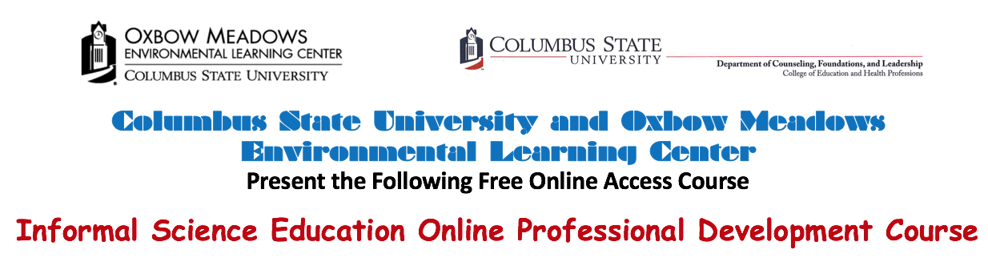
This online course is designed for formal and informal educators, who would like to take a short course in Informal Science Education. For Formal Educators, this course is a light introduction to how students learn in informal contexts. For Informal Educators, this course will provide you with an introduction to informal learning, how you could apply learning theory in your context, and evaluation.

This course consists of 6 short Modules. You may complete the course at your own speed. However, a Module should take about one week to complete. The Modules included in the course:
Module 1: Getting Started
Module 2: Defining Informal Science Education and Learning Outside the Classroom
Module 3: Learning Theory (Epistemology) and Pedagogy
Module 4: Making the Most out of Field Trip Experiences
Module 5: Evaluation
Module 6: Thank You and Final Course Survey
When you complete the course, you will receive a certificate of completion (20 hours) from Columbus State University and Oxbow Meadows Environmental Learning Center.

The course is taught by:

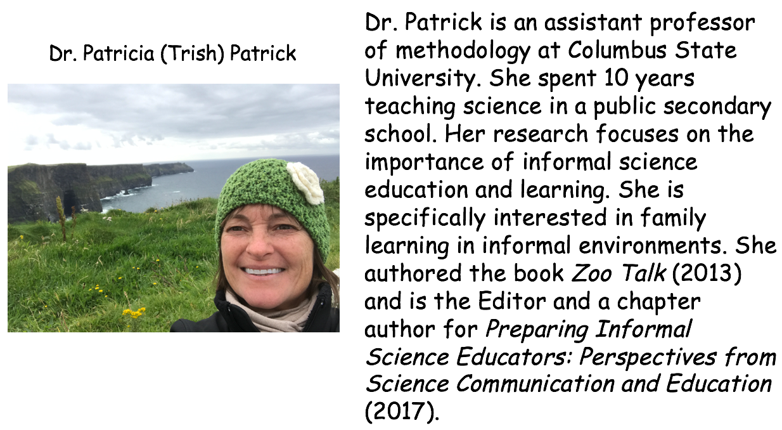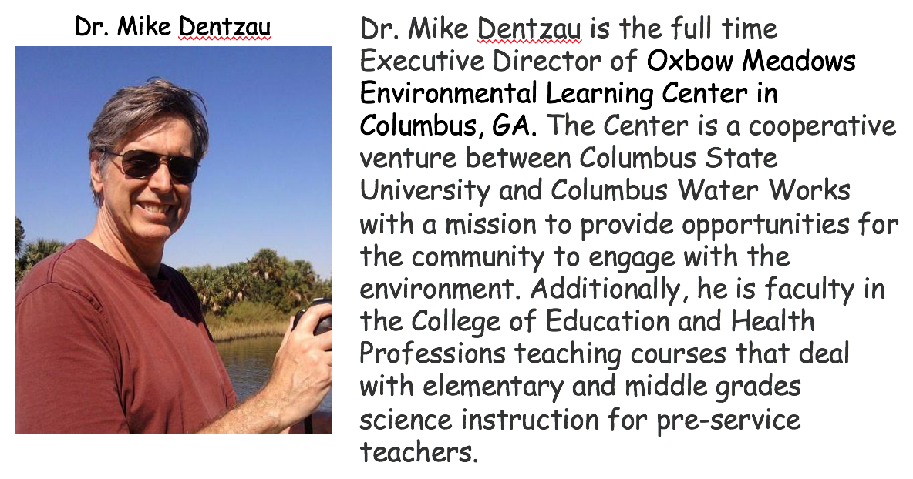

If you have questions or would like to sign up for the class, please contact us at
patricia_patrick@columbusstate.edu or dentzau_michael@columbusstate.edu

