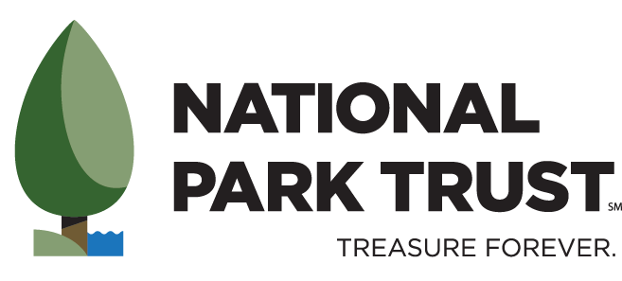
KIDS TO PARKS DAY
NATIONAL SCHOOL CONTEST

Dear Students, Parents, Teachers, and Administrators,

Kids to Parks Day is May 16, 2020! National Park Trust (NPT) invites students across the country to participate in the 10th annual Kids to Parks Day (KTP), a nationwide grassroots movement to celebrate America’s parks and public lands.

In honor of this day, NPT is once again hosting the Kids to Parks Day National School Contest to help educators engage their students with their local parks. This national contest is open to all Title I schools in the United States (grades pre-K through 12). Classes can receive funding for a KTP event at a local park or public land/waterway in their community. Students must research and write the proposal themselves. (Though we encourage teachers to provide support and feedback!) Teachers and staff will have a short section to complete as well. Your entries should explain how your experience will promote education, health and wellness, and park stewardship. NPT will award park grants up to $1,000 to winning entries. We encourage schools to implement their KTP event during the month of May 2020 but exceptions can be made based on school schedules.

The deadline for entries is Friday, February 14, 2020. Winners will be announced on our website Friday, March 6, 2020: https://www.parktrust.org/kids-to-parks-day/school-contest/

To enter:
- Students select any park or public land near their school. All parks are eligible: county, state, national, etc.
- Students research the park to find out what outdoor recreation activities, educational programs, and park stewardship opportunities are available on site.
- Complete the entry form attached. Please submit only one form per class/grade.
  - Teachers/staff complete the teacher section.
  - Students complete the student section.
  - If younger students are unable to write the entry themselves, we encourage you to provide student work demonstrating their participation in the creation of the proposal.
Details:
- One entry form can be submitted per class/grade. More than one entry form can be submitted per school.
- We want to hear from the students! Help them develop their ideas, but allow them to complete the proposal in their own words. You may provide feedback and support.
  - Entries should be appropriate for the student grade level. For example, high schoolers should write more than one sentence explaining their ideas, while a kindergartener may only provide a drawing with an explanation from the teacher.
- Be creative! Include photos, artwork, or a video as a part of your entry.
- Priority will be given to schools demonstrating need. If your school is not publicly listed as Title I, you may need to provide additional documentation. Cover letters from teachers are encouraged to provide evidence for the need for resources.
Contest winners will receive:
- Funding of up to $1000 for one park experience including school bus transportation, park-related fees, educational materials, supplies for a park stewardship project, or any other aspects students believe will enhance their park experience.
- Official award certificate and KTP stickers for students.
- Classroom Buddy Bison, our pint-sized woolly mascot, to take on your park adventure.
- A story about your experience may be featured on our website, in our e-newsletter, or on social media.

Winning submissions must agree to:
- Send at least 10 digital photos from your park trip. Photos should include your students learning, enjoying, and experiencing what the park has to offer. Please include little Buddy Bison in the pictures as well!
- 1 or more paragraphs summarizing and reflecting on the experience, and preferably at least one from a student and one from the lead teacher. (One summary per entry is required, but more are welcomed).
- Additionally, teachers are required to complete a brief online survey.
- If possible, use social media to share your park experience with the community, tagging National Park Trust and using hashtags associated with Kids to Parks Day. The classroom can choose what social media platform they would like to use (Facebook, Twitter, or Instagram). Classrooms that do not have access to social media platforms agree to provide at least one digital photo of students on their park experience within 2 days of the trip in order for National Park Trust to share the experience via social media.
- All required materials must be received by two weeks after your trip or by June 12, 2020, whichever is sooner. Failure to fulfill this obligation may result in disqualification from entering the contest in subsequent years.

Please note: any photos or written materials received may be used in NPT’s publications or materials, including our website, e-newsletters, slideshows, social media, etc. for educational or marketing purposes. If provided, we may use first names of students.

The entry form and all materials should be sent to NPT using one of the following methods:

Mailing Address Email Address Fax
National Park Trust KTPcontest@parktrust.org 301-279-7211
c/o KTP Contest
401 E. Jefferson Street
Suite 207
Rockville, MD 20850
Office Phone: 301-279-7275

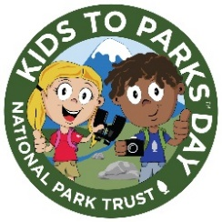
Kids to Parks Day National School Contest Entry Form 2020

Contest Deadline: February 14, 2020 Winners Announced: March 6, 2020
Entries must be prepared by students in their own words or include auxiliary student work to demonstrate their participation. Students are encouraged to be creative. Videos, pictures, and drawings are encouraged to supplement the proposal. The entry form may be typed or handwritten with legible writing. All materials received will be used for educational purposes and are the property of National Park Trust.

Teacher/Staff Section
Name of School: | Staff Contact: | Best time to contact?
School Address: | Staff Contact Number: School -  Cell -
 | Staff Contact Email:
Grade and # of Students: | % Students from Low-Income Families:
Park Name:
How did you hear about this contest? ☐NPT Email ☐NPT Website ☐NPT Social Media
Check all that apply. ☐Teacher Association ☐Returning Participant ☐Online Ad
☐ Other Participating School ☐Other. Please specify:

Provide evidence of your students’ participation in the completion of this project, their desire for this trip, and their need for this grant in order to make this park experience possible. Please feel free to attach a separate cover letter or student work in addition to the short response space provided below.
________________________________________________________________________________________________________________________________________________________________________________________________________________________________________________________________________________________________________________________________________________________________________
Student Section

Submitted By: _________________________

- What do you plan on learning while at the park?

- How are you going to promote a healthy life style while visiting the park?

- How can you leave the park a better place? How can you be a steward for the park?

- Why do you think your class should be selected as the Kids to Parks™ Day National School Contest Winner?

Budget for Park Visit

Students - please complete the brief budget for your park trip

Item | Explanation | Cost
Bus/transportation
Contact your bus company for pricing.

Park Experience/other fees
Canoe rentals, park entrance fee, guided tour, etc.

NOTE: Zoos and aquariums are
NOT eligible unless a strong natural park element is included.
Stewardship Project
Plants, mulch, cleaning supplies, trash bags, vinyl gloves, etc. Contact park to determine their needs.

NOTE: We cannot provide funds specifically for park donations or animal “adoptions”.

Other
Small snacks, water, educational materials, etc.

NOTE: We cannot provide funds for lunches, t-shirts, or souvenirs.
Total:

