This is the second article in a series about global environmental issues, especially as viewed, investigated, and understood with the lenses of the 7 Crosscutting Concepts (CCCs) that are an integral part of Next Generation Science Standards (NGSS). The first article focused on the phenomena of our current three global environmental crises: climate change, biodiversity extinctions and increasing pandemics. We tend to analyze and discuss these crises separately. From a causal perspective, there are significant differences in the main direct cause(s) of each of these. Yet all three crises are ultimately the result of one general cause: human actions are significantly endangering human societies and Earth’s web of life.
The diagram below comes from UC Berkeley’s Understanding Global Change (UGC) Project ((https://ugc.berkeley.edu). It is a systems model designed to help explain one major way that climate change is endangering human societies. The UGC project has developed a rich variety of tools and downloadable resources to help create models of global change phenomena. For example, students can use UGC’s generalized Earth scene as a background for constructing models. Teachers and students can insert icons, arrows, and textual references to illustrate and explain a chain of causal changes leading to the displacement of human populations due to sea level rise.

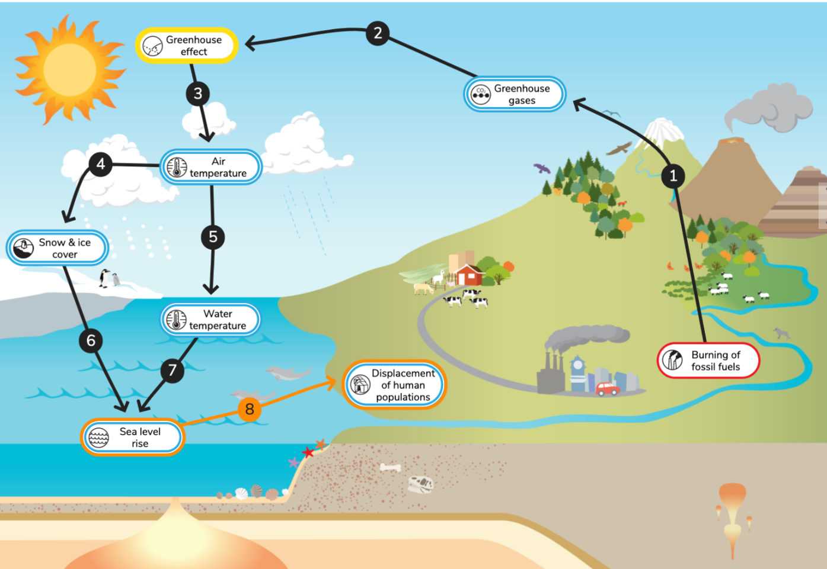

Our planet is a very complex, dynamic system that is resilient and has feedback loops that stabilize its systems and other feedback loops that can cause catastrophic results. We were not born with the natural skills to readily envision these complex relationships, explain them to ourselves and others, and make the best choices of actions. We need to consciously develop system thinking skills, and effectively apply them.
To really appreciate the power of systems thinking, I emphasize two words and one concept. The two words – “emergent properties.” The concept: a system generally has features or properties that are very different than those of its components. Both the two-word phrase and the concept apply to very simple systems as well as complex systems.
Table salt (sodium chloride) is an example of a system. It is made when sodium and chlorine combine with each other. Sodium is a silvery metal that reacts violently with water, releasing hydrogen that can catch on fire. Chlorine is a poisonous greenish gas that is also highly reactive. Unlike its metallic and gaseous parts, table salt is a crystalline white solid that is unreactive. We put it on our kitchen table and sprinkle it on our food.
Because students learn about body systems and ecosystems, they are familiar with the science use of the word. However, they have not been taught to recognize and appreciate how different a system is from its parts. In teaching about climate change, it is helpful to ask students where their body temperature comes from. Is it a part of their blood because they are “warm blooded?” What part of their body made the heat and keeps it constant except when they get sick or overexposed to cold or heat?
The answer is that our body temperature emerges from the interactions of all our body parts with each other and with the physical environment. An unconscious subsystem within the human body keeps track of the internal temperature and makes adjustments to keep it within a healthy range. This is lifesaving. Very dangerous consequences happen when body temperature is 4 to 6 degrees F hotter or colder than normal.
Earth’s temperature is now more than 2 degrees F hotter (1.2 degrees C) due to the increased greenhouse effect. At first that might not seem like a very significant temperature change. However, the situation is similar to that of our body systems. Increasing the global temperature by 4 or more degrees F would have huge, very long-term, negative consequences for humans and for Earth’s web of life.
Like human body temperature, Earth’s temperature and global climate are emergent properties of the Earth system. No individual part of the Earth system has a global climate. Earth’s global climate arises from the way the parts of the planet interact with each other and with the sunlight that reaches the planet. We have changed those interactions in ways that are already leading to increases in extreme weather events.
Emergent properties also explain things that amaze and enlighten us about ourselves. The life of single cell and multicellular organisms emerges from how their parts work together and with the environment. Our awareness of ourselves is an emergent property resulting from interactions among our nervous system and other body systems. My personality is an emergent property of my genetics and all my environmental influences.
Emergent properties have profound effects at the level of societies. Ant colonies provide a surprising example. An ant colony can have ant farms, baby nurseries, organized wars, and special food storage facilities. It operates as if the nest is aware of itself and plans how its members will have different jobs to meet the nest’s needs and solve any problems. Most people probably think the Queen Ant is in charge. Actually, she makes babies in a very isolated location, and knows practically nothing about how the nest operates as a whole. And there is no king.
The incredible organization of ant colonies results from the huge number of unthinking interactions among the individual ants inside and outside the nest. Each of those ants is instinctively obeying a set of ten or fewer simple rules that determine at any moment where it goes and what it does. Evolution has perfected these ant behavior rules and interactions so they result in the emergence of nest structures and colony behaviors that make ants one of Earth’s most successful organisms. The structures and behaviors of ant colonies are all examples of emergent system properties.
Human societies appear to be very different from an ant colony. We have leaders of countries, sports teams, and companies who are supposed to be aware of their whole system and who give orders about how things should be done. We are more top-down than an ant colony. However, what actually happens in a country, company or sports team is caused at least as much by the cumulative effects of what its people do individually and collectively. With respect to our current environmental crises, our collective behaviors are causing them. A more hopeful systems-based conclusion is that by collaboratively changing our actions, we could collectively cause the emergence of sustainable neighborhoods, states, countries, and geographical regions.
The power and transformative potential of emergent system properties is the main reason that I titled this essay “Systems: The Super CCC.” Even though NGSS does not emphasize emergent system properties, it does incorporate the power of systems thinking in a different way. I have summarized in the chart below some of the connections between systems thinking and each of the 7 Crosscutting Concepts.

Connecting Systems Thinking and the Seven Crosscutting Concepts
Name of CCC | Relationship With Systems Thinking
Patterns | We naturally look for and recognize patterns. We can represent a pattern in a system model and decide if that representation helps us understand the phenomenon or system we are investigating.
Cause and Effect | We naturally assign causes to events. We are not always right. System models frequently have arrows from causes to effects. These causal connections can then be used to make predictions or explain the mechanism of how the cause makes the effect happen.
Scale, Proportion,  and Quantity | We are terrible at understanding scales of size, time, and energy that are different from ours. Comparing models of a system at different scales can help us avoid common mistakes such as thinking rock molecules are harder than butter molecules.
Systems and System Models | We do not naturally think in terms of systems, but we need the systems perspective to understand our complex world. Systems modeling is a great way to begin systems thinking, especially when learners keep improving the model based on further research and results from testing model-based predictions.
Energy and Matter | Many phenomena can be better understood by tracking the flows of matter and energy into, within, and out of the system that is being studied to understand a phenomenon.
Structure and Function | This CCC focuses on objects. Every object is a system made of parts. The function of an object emerges from the interactions of the parts. Functions of tools or of organism structures are emergent system properties.
Stability and Change | In describing this CCC, NGSS states that for natural and designed systems, stability and change are crucial elements to consider and understand. Whether and how a system changes often provides strong evidence for explaining a phenomenon.

