Cornell University New Online Course April 10–June 4, 2017
Urban Environmental Education

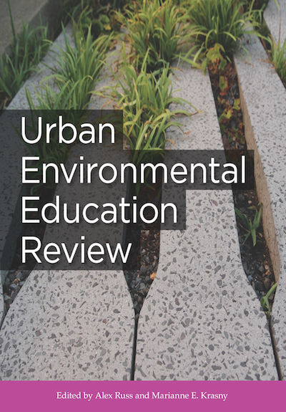
CORNELL UNIVERSITY CIVIC ECOLOGY LAB
Facilitators: Alex Kudryavtsev, Yue Li, Marianne Krasny
Syllabus: https://civicecology.org/course-UEE
This course is based on the Urban Environmental Education Review textbook http://tinyurl.com/UEERbook. It covers learning in urban environments, inspiring educational programs from cities around the world, and applications for developing and improving your own environmental education programs. Learn from video lectures and readings. Exchange ideas with other course participants and facilitators. Earn a Cornell Achievement Certificate after 6 weeks and a Cornell Expert Certificate if you also submit a course project during additional two weeks. Participants with any level of experience and from any country welcome.
Cost: $50. As part of our commitment to making our online courses available to anyone anywhere, and to creating a rich global online learning community, those without the ability to pay can sign up for free. We also offer participants a $100 registration fee option to anonymously sponsor a student who is unable to pay. Course includes free access to 25 textbook chapters. Register by April 9th!
Environmental Education for Sustainable, Just, and Livable Cities
_______________________________________________________________________________________________________________________
Enroll yourself ($50): www.ecornell.com/UEE
Enroll yourself and sponsor another student ($100): www.ecornell.com/UEESponsor
If you are unable to pay, contact helpdesk@ecornell.com for assistance with enrolling.

