A unique professional
development experience for
middle- and high school teachers.
Arctic Plant Phenology - Learning through Engaged Science
Summer workshop June 26-29, 2017
University of California, Davis
Teachers will have the opportunity to engage and collaborate with leading polar research scientists and science educators. You will spend 4 days at the University of California, Davis learning about the study of phenology – the seasonal dynamics of plants and animals - in the Arctic to understand ecological impacts of climate change. Focusing on the 3-dimensions of NGSS, you will engage in inquiry-based activities that replicate approaches used by scientists in investigating key environmental processes linked to species survival. With support from the APPLES team, you will develop a research project to implement with your students in the 2017-2018 academic year. The classroom research project will incorporate concepts from the workshop, arctic data collected by Dr. Eric Post and students, and methodology and equipment (experimental warming chamber, plant phenology camera ) used by researchers.
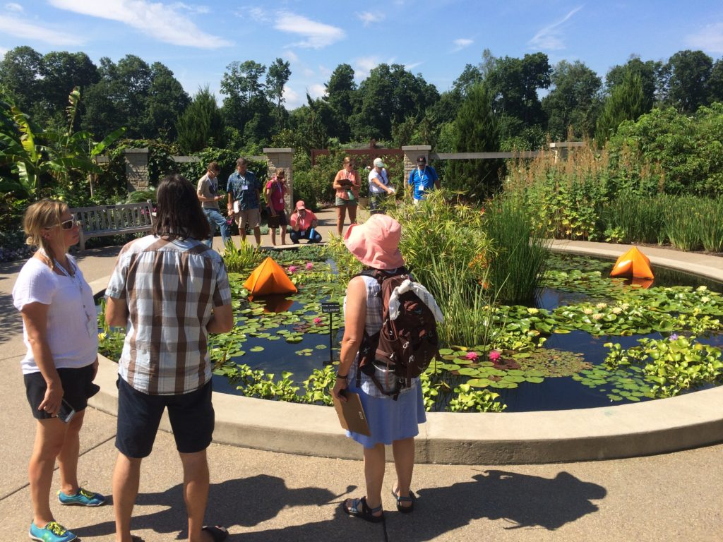
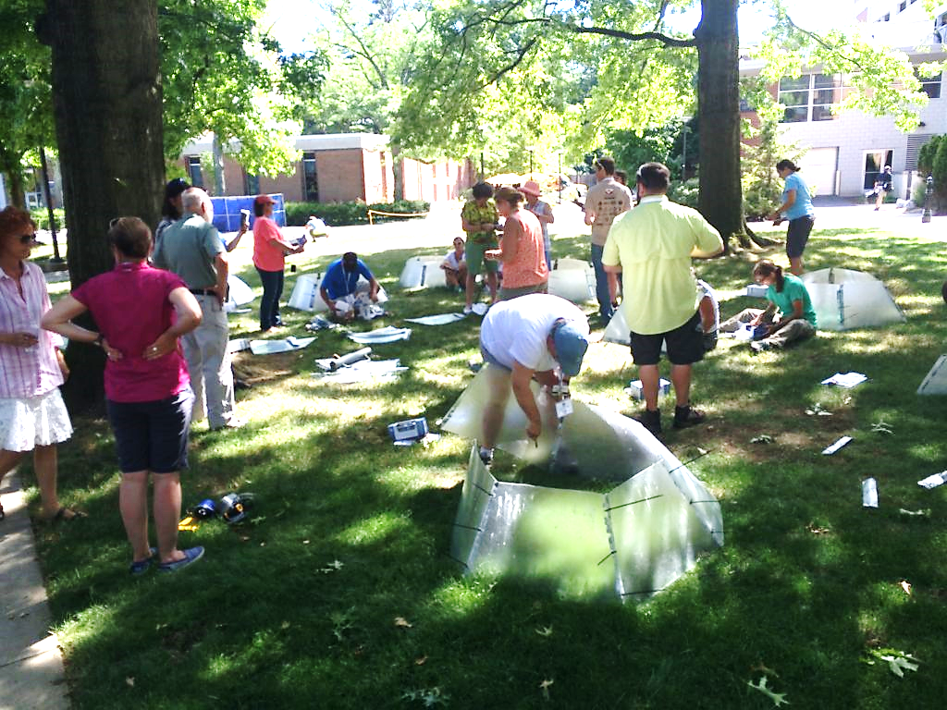
This free workshop is
limited to 15 participants,
so register early!
Deadline: April 1st, 2017

Teacher Benefits:
- Activities emphasize the 3-dimensions of Next Generation Science Standards
- Lodging and meals are provided during the workshop; travel support available
- Equipment needed to carry out classroom research projects
For more information visit applesproject.org or
contact Pernille Sporon Boving at boving@ucdavis.edu
Apply Here: www.csats.psu.edu/overview-of-csats-programs/summer-workshops

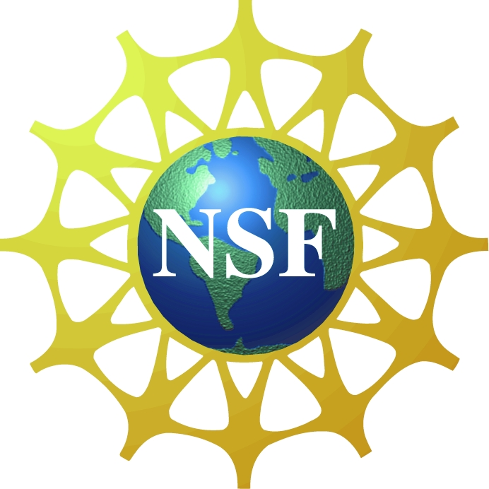
National Science Foundation Grant #1525636

